[TopCoder Direct]
Conceptualization Phase

Conceptualization Document

Template v 1.0

6/28/2012

Medicaid Provider Screening Portal:

Screening Rules for Selected Provider Types – Part 1
Table of Contents

1.0 Introduction 3
1.1 Overview of Application 3
1.2 Project Objectives 6
1.3 Assumptions 8
1.4 Limitations 8
1.5 Open Items and Risks 9
2.0 Existing Business Flow 11
3.0 Proposed Workflow 12
3.1 Overview 12
3.2 Context Diagram 33
3.3 High Level Workflow 35
3.4 Use Case Diagrams 53
4.0 Business Requirements 55
4.1 Users 55
4.2 Inputs/Outputs 55
4.3 Dependencies 59
4.4 Task Requirements 60
4.5 Security Requirements 72
4.6 Performance Requirements 72
4.7 Data Migration 72
5.0 Appendix 73
5.1 Tribal Codes 73
5.2 Categories of Service Codes 73
5.3 Specialty Codes 76
5.4 License Codes 82
5.5 Major Program Codes 85

Introduction

Overview of Application

The client for this project is the Minnesota Department of Human Services (MN-DHS). The MN-DHS compensates medical service providers through a healthcare program called Medicaid. Medicaid is funded by the United States government, and it is operated by individual states (including the MN-DHS). Medicaid provides health benefits to more than 60 million Americans which include children, parents, senior citizens, pregnant women and disabled people.

New regulations (effective March 25, 2011) require all newly enrolling health care providers who participate through Medicare, Medicaid and CHIP to complete a "Risk-Based Provider Screening" process. Providers who are currently enrolled must be re-enrolled at least once every five years, and they must also go through the “Risk-Based Provider Screening” process as well.

MN-DHS's current Provider Enrollment systems must be modernized in order to meet the demands of these new federal regulations. They estimate around 44,000 provider enrollment screenings will be required annually, and their current staff and systems cannot process this high volume of screenings as it is.

To solve this problem and process provider enrollment and renewals in compliance with the new Provider Screening Regulations, a large IT project has been launched to build a system called the Medicaid Provider Screening and Enrollment (MPSE). Several key components have been identified for the overall MPSE project:

- A front-end Provider Enrollment Processor (PEP),
- A back-end Provider Validation Service (PVS), and
- Related MMIS System and Associated Database changes (the current MN-DHS system)

For this particular piece of the project, only the Provider Enrollment Processor (PEP) component is in scope.

The front-end PEP application is responsible for collecting required provider based data and scanned images (medical certificates and licenses). It also has the ability to collect payment (if applicable) and to send collected data to external systems, such as the SIRS Site Visit and NetStudy background check systems. Additionally, it will send and receive data from both the back-end PVS system and the existing MMIS system (both out of scope for this piece of the project).

The front-end Provider Enrollment Processor (PEP) system will utilize a dynamic set of business rules to collect the appropriate needed information and direct the enrollee to the various areas of the application to be completed based on preset parameters, such as provider type or level of assigned risk (Limited, Moderate, or High).

Essentially, the PEP serves as the starting point for all new applicants seeking to enroll and for existing providers seeking re-enrollment. It also applies to any provider when a change to their data may trigger additional screening or follow-on actions (e.g., a change of ownership). It serves as both the brains and the gatekeeper for all downstream processing as data collected in this stage determines what has to take place at the various junctures to comply with the screening regulations.

A previous TopCoder Conceptualization contest (“Medicaid Provider Screening Portal Application Conceptualization 1.0”) has been completed to define the basic system design of the PEP application. This contest will serve as supporting documentation for that existing conceptualization document, and will dig deeper into the details around the business rules necessary for the PEP application.

The business rules for the provider enrollment and screening process is an important piece of the project. The PEP will assign a potential level of risk to each registrant, and will do this by applying a suite of dynamic business rules. Once a level of risk has been assigned, the registrant's application will be sent to the appropriate sub-system for additional screening and processing.

This conceptualization document will capture the common business rules and requirements necessary as part of the Provider Enrollment Processor, as well as business rules specific to the following list of selected providers:

- Audiologist – Provider Type 43
- Certified Professional Midwife – Provider Type C1
- Community Health Care Worker – Provider Type 55
- Clinical Nurse Specialist – Provider Type 68
- Certified Registered Nurse Anesthetist – Provider Type 67
- Chiropractor – Provider Type 37
- Podiatrist – Provider Type 36
- Licensed Marriage and Family Therapist – Provider Type 25
Licensed Psychologist – Provider Type 42

Application Problems

The current process is manual and requires a significant amount of time and effort for the registrant to complete.

The current enrollment process is not easy to follow from start to finish, and assistance must frequently be given to providers throughout the process.

The current process does not include any type of automatic validation since information is entered manually on forms.

The current process does not include a set of dynamic business rules for individual provider types. Additionally, the current conceptualization document (“Medicaid Provider Screening Portal Application Conceptualization 1.0”) does not contain screening rules for individual provider types.

The current process lacks automatic risk assessment based on the input of providers while completing their enrollment forms.

Application Opportunity

There is the opportunity to allow registrants to complete the provider enrollment and screening process through the new, automated application.

The opportunity exists to validate enrollment data as it is entered to confirm it is correct.

The opportunity exists to assign a potential level of risk to each registrant by applying a suite of dynamic business rules.

There is the opportunity to create a common workflow that all providers go through for the screening and enrollment process.

There is the opportunity to create a dynamic set of business rules for each individual provider type.

The opportunity exists to verify providers are not included on a sanctions list, and to reject their application if they are.

The opportunity exists to allow providers to submit their required licenses and certifications through the new application. Once these licenses / certifications are submitted they can be verified through the correct source based on the provider type.

There is the opportunity to provide details on the business rules for selected provider types listed above to enhance the existing conceptualization document (“Medicaid Provider Screening Portal Application Conceptualization 1.0”)

Definition of Terms and Acronyms

CMS | Center for Medicaid Services
Categories of Service | Types of services the provider can provide
CHOW | Change of Ownership – Occurs when a business is sold and the new owner changes the FEIN and NPI. In that case, the old record is terminated and a new one is created.
EFT | Electronic Funds Transfer
EPLS | Excluded Parties List System - EPLS provides a single comprehensive list of individuals and firms excluded by Federal government agencies from receiving federal contracts or federally approved subcontracts and from certain types of federal financial and nonfinancial assistance and benefits
GUI | Graphical User Interface
HCFA | Health Care Financing Administration (Sanctions List)
Individual Practitioner Enrollment Application (DHS-4016) | A standard enrollment form for providers to fill out (the provider enrollment form in the current system). Used for collecting the majority of provider data for the enrollment and screening process.
IT | Information Technology
Major programs | Major programs are the programs Medicaid covers
MMIS | Medicaid Management Information Systems - the current system in place today
MN-DHS | Minnesota Department of Human Services
MPSE | Medicaid Provider Screening and Enrollment
MPSP | Medicaid Provider Screening Portal
NetStudy | An external background check system
NPI | National Provider Identifier. Similar to a social security number, but for a health care provider. Instead of each insurance company assigning their own ID and the provider needing to keep track of them all, the NPI identifies them with everyone. Type 1 NPI is assigned to individuals, and type 2 is assigned to organizations. Not all providers are required to have an NPI.
NPPES | National Plan & Provider Enumeration System - NPI NPPES Registry Search Website is used to verify NPI numbers
PADD | PROVIDER ADDRESS (Screen Representing Data In The Current System)
PBCK | Provider Criminal Background Check
PCOS | Provider Categories Of Service
PEP | Provider Enrollment Processor (Frontend)
PFIN | Provider Financial Data
PGRP | Groups / Billing Agents
PIAPD | Planning and Implementation Advance Planning Document
PINF | Provider Information
PLIC | Provider Licenses
PMBR | Individual In Group
PPGM | Provider Programs / Alternate Mailing Address
PROL | Provider NPI
Provider / Enrollee | The medical service provider who is using the new system to enroll or re-enroll through the Risk-Based Provider Screening process
Provider Agreement (DHS-4138) | A standard agreement form providers need to sign
PVS | Provider Validation Service
Selected Providers | The specific provider types covered in this document (see list in section 1 above)
SIRS | Surveillance & Integrity Review Section – An external system for site visits
Specialties | Specialties are the specific services a provider can provide
UI | User Interface
UMPI | Unique Minnesota Provider Identifier. Assigned to providers that are required to have an NPI.

Project Objectives
The business objectives of this project are listed below. Delivering these objectives will deliver the expected benefits of the application.

NOTE: This is a non-standard conceptualization contest with a focus on business rules and workflow. The screening and business rules captured in this document are a component within the overall Medicaid Provider Screening Portal, which is defined in the conceptualization document from the previous Medicaid Provider Screening Portal Application contest. This document enhances the previous document (including objectives) and will NOT re-do the work from the previous contest, except where that one was wrong.

Must Have:

- To design a set of screening rules and workflows to expand on the enrollment component of the Medicaid Provider Screening Portal Application (system design included in the conceptualization document from the contest “Medicaid Provider Screening Portal Application Conceptualization 1.0”).
- To define a common workflow for collecting enrollment information of individual providers.
- To define the screening/validation rules and workflows for the following Individual Provider Types:
    - Audiologist – Provider Type 43
    - Certified Professional Midwife – Provider Type C1
    - Community Health Care Worker – Provider Type 55
    - Clinical Nurse Specialist – Provider Type 68
    - Certified Registered Nurse Anesthetist – Provider Type 67
    - Chiropractor – Provider Type 37
    - Podiatrist – Provider Type 36
    - Licensed Marriage and Family Therapist – Provider Type 25
    - Licensed Psychologist – Provider Type 42
- To support the ability to ask only for relevant information from the user (based on provider type).
- To support the ability to validate provider data against the screening rules for their specific provider type.
- To support the ability to verify licenses and certifications of enrolling providers (automatic verification is the preferred approach by the client).
- To support the ability to upload scanned copies of forms and licenses for verification.
- To support the ability for providers to submit signed forms required for enrollment (required forms determined by their provider type).
- To calculate the risk level of enrolling providers.
- To verify that users are not included on sanctions or exclusion lists
- To have the ability to reject user applications if they are found on sanctions or exclusion lists.
- To send provider data to the PVS and MMIS systems based on the results of screening and enrollment, including results from risk assessment.
- To support the ability to send provider enrollment applications to external systems (such as SIRS System and NetStudy) for additional checks based on calculated risk level.
- To support the ability to validate the NPI number entered by the provider.
- To support the ability to generate a unique identification number (Unique Minnesota Provider Identifier) for the provider if NPI is not entered (and not required).
- To build an application with the ability to send a request to the MN-ITS system to create a mailbox account for the enrolling provider.
- To design an application that complies with Section 508 of the Americans with Disabilities Act requirements.
- To build an application with the ability for users to request help.
- To build an application with the ability to check and see if users exist in the Medicaid Provider Screening Portal system already.

Nice To Have Features:
- The ability to have providers enter their license or certification number and have it automatically verified through the correct organization is a nice to have feature the client would like to have (open issue for architect)

Assumptions
Some assumptions generally must be made in order to write a succinct definition of the application. Some assumptions are technical (e.g. “the new system will employ a normalized database schema”); while others are business natured (e.g. “the client will provide an enterprise Oracle environment”). Assumptions critical to the success of this project are listed below:

- The business processes, screening rules and workflows defined in this document expand on the conceptualization document from the previous Medicaid Provider Screening Portal Application contest. This document is for a component of the overall system described in that document, so overall system functionality covered in the previous document (like login, logout, auditing, logging, etc.) can be left out of this submission unless a change is needed.
- It is assumed that the reader of this document is familiar with the previous MPSP conceptualization document since this expands upon it.
- Every provider type will have Major Programs (but different combinations).
- Not every provider type will have a Specialty Code.
- Providers only need to agree to Rule 101 when they've decided to limit their patient caseload to 10%-20% (depending on provider type) of Medicaid patients, if they are limiting everyone regardless of insurance, or if they are limiting everyone except children with special health care needs or managed care organization patients.
- The enrollment process is the same as the re-enrollment process (meaning the business logic and screening process is the same for both a new provider enrolling and a current provider re-enrolling).
- All provider types covered in this document have the same access in the application (Service Provider role), although each provider type has a different set of business rules and a different workflow to follow.
- The application will use a combination of provider type and services to determine the risk of some of the Medicaid only providers.
- Not all providers are required to have an NPI. In those cases where it is not required, they are assigned a Unique Minnesota Provider Identifier. This rule will be based on the provider type.
- NPI Type 1 is assigned to individuals. NPI Type 2 is assigned to organizations.
- Provider pre-populated data is only sent to SIRS Site Visit for moderate or high risk providers.
- Background check data is only sent to NetStudy for providers identified as high risk or with 5% or more ownership.
- Background checks (via NetStudy) are required for certain individual provider types (list to be provided).
- Providers found on the sanctions list will be rejected automatically.

Technical Assumptions:
- The screening and business rules defined in this document will be used as part of the Medicaid Provider Screening Portal Application, and will use the same technologies as that system.

Limitations
Every project has limitations on the scope of the problem it attempts to solve, on the capabilities of the implementation technology, etc. Some limitations are assumptions on the extent of feature scope. Others are restrictions on resources or methods for achieving the objectives. The limitations of this project are listed below:

- This document will only capture the business processes, screening rules and workflows for the selected providers listed above (other providers are captured in separate documents).
- This document will focus on screening rules and workflows, it will not repeat system functionality captured in the previous Medicaid Provider Screening Portal Application conceptualization document.
- The application and business rules for this contest will only cover Individual enrollment. Organization (group) enrollment is out of scope.
- Changes of Ownership (CHOWs) are out of scope for this phase of the project.
- “MAPS” is a system that is no longer used in the enrollment process and is not in scope for this project.
- SharePoint is an internal system the client uses for collaboration. It doesn't interact with the current enrollment system, and is not going to interact with the new system.
- FileNet is the client’s electronic document filing system. It is not used for license or sanctions verification and will not be used in the new system.
- MN-ITS will not factor into provider screening rules (it is only used to create provider mailbox accounts and contains provider details related to billing).
- The purpose of this document is to extend the previous Medicaid Provider Screening Portal Application documentation. It will not be combined with this previous document as part of this contest (previous submission not updated).
- This document focuses on the selected provider types; therefore functionality for other user types of the MPSP application (such as actions performed by service and system users) is not covered here.
- The Medicaid Provider Screening Portal application contains functionality for sending email notifications so this functionality is not captured in this document.
- The MPSP application includes logging and auditing functionality, so the component in this document does not need to.
- The MPSP application includes user login, authentication, and authorization functionality so it is not covered in this component.
- Provider Validation System (PVS) is out of scope for this particular project.
- The MMIS system is not in scope for this project.

Open Items and Risks
During the conceptualization of the project and in the process of writing this document, some issues may have been discovered, and others may remain open.

Open Items and Risks for the Next Phases of the Application

- The look and feel of this component is not yet defined. TopCoder Studio contests may be run to define the look and feel and how this component fits into the overall Medicaid Provider Screening Portal Application UI.
- The data field mapping from collected provider data in the new system to the screens of the current system has not yet fully been defined. This data mapping must be completed during the next phases of the project (specification or architecture)
- A full list of all the available data fields and their meaning in the current system has not yet been provided. This will be needed for the next phase
- For all provider licenses and certifications, their method of input is still an open issue. The client has requested that ideally the system should allow the user to enter their license / certification number and have it automatically verified. However, due to the large number of providers supported by this application, and the fact that all require different license / certifications, this request could prove challenging (it is dependent on the verification systems available for each different provider). Submitting (uploading) a scanned copy is a backup if automatic verification isn't feasible. The final decision on this will need to be made through discussions between the client and the architect.
- The results of the disqualification questionnaire and what risk level will be assigned based on “yes” responses is still an open issue. The assigned risk level and next steps to take based on the answers must be defined in the next phase of the project.
- The risk rules based on provider type and services have not yet been defined and are an open issue.
- There is an open issue for the client to provide business rules based on provider type and which providers require an NPI.
- There is an open issue on how a provider submits a signed form / signature. The decision between e-signing and submitted a signed copy (uploading) needs to be determined during the architecture phase of the project. This decision will ultimately need to be decided by the client to ensure the method chosen meets all legal requirements.
- The screening rules documentation mentioned a "list of county codes" given to every enrollment specialist. This list will need to be provided by the client.
- A list of individual provider types that will require a background study (via NetStudy) still needs to be provided by the client (open issue).

Open Items and Risks for the Next Versions of the Application
- To support “nice to have” objectives if they were not achieved in the current version of the application.
- In the future, the application and business rules will support Organization (group) enrollment in addition to individual enrollment. There will also be a user role (Service Agent) for a person authorized to complete enrollment for Organizations.
- The application will support CHOWs in the future.

Existing Business Flow

If this is an entirely new application, this section should be completed only if there is an existing business process.

This project is for a new application so this section is not necessary (as confirmed by the client)

Proposed Workflow

Overview
This section includes a concise description of the features and operation of the proposed solution. It also compares and contrasts the solution with the current process. The context and workflow of the proposed solution are defined in subsequent sections.

The new, front-end MPSP system will collect provider data based on business rules for each specific provider type. Once the application has collected and validated this data, it will assign a risk level to the provider (based on the data collected). Below, the workflow and business rules are captured for specific provider types: Audiologist, Certified Professional Midwife, Community Health Care Worker, Clinical Nurse Specialist, Certified Registered Nurse Anesthetist, Chiropractor, Podiatrist, Licensed Marriage and Family Therapist, and Licensed Psychologist.

Comparison with Old Approach

In the old system, enrollment forms were completed manually by providers and processed manually by employees of the client.
- In contrast, the new system will allow registrants to complete the provider enrollment and screening process through the new, automated MPSP application.
- The registration will follow a basic common enrollment workflow that automatically takes the provider through each step of enrollment.
- The new application will also include provider specific workflows for each provider type during the enrollment process. The enrolling provider will go through this workflow specific to them and they will only need to complete steps necessary based on their provider type.
- The business rules and workflows will be built into the new application so users will not need to read confusing steps on a form to figure out what information they must complete or skip.

In the old system, there is no easy way to validate enrollment data as it is entered by the provider to confirm correctness.
- In contrast, the new system will validate input once it has been entered by the provider.
- Validation will be completed automatically by the application by following a defined set of business rules for each different provider type.
- Data that must be entered into the current MMIS system in a certain way will be run through Data Consistency Rules to make sure it is entered correctly.

In the old system, there was no way to automatically calculate the risk level of a provider as they completed the enrollment process.
- In contrast, the new system will calculate the risk of providers based on a series of questions they are asked.
- The new system will also check providers against a sanctions list and an exclude list to see if they are included. Providers found on one of these lists can be automatically rejected.
- The new system will also support license and certification verification to ensure providers meet the necessary licensing requirements for their provider type.
- Risk assessment will follow a set of business rules, and the enrollee data will be sent to the appropriate systems based on the results.
- If a provider is determined to be a high risk, the application will automatically send their application to external systems for additional checks (background check, SIRS site visit, etc.)

In the existing conceptualization document (“Medicaid Provider Screening Portal Application Conceptualization 1.0”), the overall PEP system is covered but the business rules for selected provider types are not explained in detail.
- In contrast, this document will focus on the business rules for the following select provider types:
  - Audiologist – Provider Type 43
  - Certified Professional Midwife – Provider Type C1
  - Community Health Care Worker – Provider Type 55
  - Clinical Nurse Specialist – Provider Type 68
  - Certified Registered Nurse Anesthetist – Provider Type 67
  - Chiropractor – Provider Type 37
  - Podiatrist – Provider Type 36
  - Licensed Marriage and Family Therapist – Provider Type 25
  - Licensed Psychologist – Provider Type 42
- Each of the above provider types will complete the common parts of the workflow, along with the steps specific to them.

New System Features

The new, front-end MPSP system will allow registrants to complete the provider enrollment and screening process. Enrollees will complete the necessary forms, and the application will include validation of data entered by these enrolling providers. Full details on functionality and features of the new MPSP application are fully defined in the existing conceptualization document (“Medicaid Provider Screening Portal Application Conceptualization 1.0”). The new system features below describe details of these screening / business rules and workflows.

Each provider will only enter the information required for their specific provider type. The application will determine which information to collect based on a set of business and screening rules for each individual provider type. In order to do this, the user will need to select their provider type.

Before starting, the application will check to see if the user has a previously saved application in progress. If they do, the system will allow the user to move ahead in the workflow, up to the section they had previously completed. They can then begin working from where they left off. If no previous data was saved, the user will begin the workflow from the beginning. As the enrollment process goes on, they will have the option to save their progress at any time. Help will also be available to them throughout the process if needed.

Once the process has begun, the user will first complete the Individual Practitioner Enrollment Application. This is the basic enrollment form all individual providers must complete. Certain sections of this form only apply to specific user types. The application will only ask providers to complete the sections required for them (based on the rules described below).

Providers will complete their profile with their personal information, along with their NPI number. If NPI isn’t entered, and it’s not required for the enrolling provider type, the application will automatically generate a Unique Minnesota Provider Identifier (UMPI) for the user. If NPI is available, the application will confirm it’s valid by checking it through the National Plan & Provider Enumeration System. The user will also answer questions about their practice, select alternate mailing addresses (and what will go to each), and the remittance sequence (sort order) they wish to receive data in.

The enrolling provider will also have to select any specialties they have. Certain specialties require a certification. In these cases the provider will be asked to submit their certification.

Each provider type also has a set of required documentation. This documentation is generally a license or certification with a specific governing board. Based on the provider specific rules, the application will require the user to submit these documents or information.

When possible, the application will automatically verify provider licenses and certifications. It will do this by connecting to the necessary verification service and checking the license number entered. If verification can’t be done automatically, it will need to be manually verified by the support staff.

Users will also be required to complete a brief disqualification survey. Based on the answers to these questions, the system will calculate a risk level for the provider. Additional risk checks will be completed, such as checking the OIG Exclusion and EPLS Exclusion lists. Users that are deemed a high risk can be sent to different systems for additional checks (or automatically rejected).

In the new system, users will also have the ability to submit signed forms. This functionality will allow users to either e-sign a required form or to upload a scanned image of the signed document (exact approach is still an open issue). Signed forms the provider can submit include the Rule 101 agreement and the ETF Authorization form.

Data entered by the provider will also be validated by the application to help ensure it is filled out correctly. It will need to follow a set of Data Consistency Rules described below. The provider specific rules will also run to make sure the provider has completed all the steps needed in the enrollment process.

Once the enrollment process is completed, the system will save the captured data and send it to the PVS system and the MMIS system. If the user passed enrollment, a MN-ITS Mailbox account will be created for them.

The above mentioned business rules / screening rules for selected provider types, along with data validation rules and risk-assessment rules, are detailed in this section below.

Risk-Assessment Rules (New System)

Providers will be asked to complete a questionnaire and truthfully answer the following questions:
- Have you ever been convicted of a criminal offense related to involvement in any program under Medicare, Medicaid, Title XX, or Title XXI in Minnesota or any other state or jurisdiction since the inception of these programs? (Yes / No)
- Have you had civil money penalties or assessments imposed under section 1128A of the Social Security Act? (Yes / No)
- Have you ever been excluded or terminated from participation in Medicare, Medicaid, Children's Health Insurance Program (CHIP), or the Title XXI services program in Minnesota or any other state since the inception of these programs? (Yes / No)

Providers who answer yes to any of the above questions will be marked a “high risk” by the system. The enrollment forms for these high risk providers will be sent to external systems for further screening.

Provider Name and Address Data Consistency Rules (New System)

Data collected through the new PEP will be sent to other systems, including the current MMIS system. MMIS already contains a large amount of provider data, so it’s important the new application follows the same data consistency standards that MMIS has in place today. Below are the rules that must be followed in the new system to ensure name and address data consistency:

- Individual Names:
  - Standard Individual Names:
    - NAME field contains - FIRST, MIDDLE, LAST, CREDENTIALS = (JAMES MICHAEL OLSON MD)
    - SORT NAME field contains - LAST, FIRST, MIDDLE = (OLSON JAMES MICHAEL)
      - Do not use titles in the SORT NAME filed.
    - INST OWNER - Leave this blank unless the provider owns the FEIN; then list the owner name as it is registered with the IRS.
  - Last names with apostrophe's:
    - NAME field - contains the apostrophe (O'CONNOR)
    - SORT NAME field - does not contain apostrophe (OCONNOR)
    - INST OWNER - Leave blank unless the provider owns the FEIN; then list the owner name as it is registered with the IRS.
  - Hyphenated last names:
    - NAME field contains - FIRST, MIDDLE, LAST-LAST (NANCY WISE-VANDERLEE MD)
    - SORT field contains - LASTLAST, FIRST, MIDDLE (WISEVANDERLEE NANCY)
    - INST OWNER - Leave blank unless the provider owns the FEIN; then list the owner name as it is registered with the IRS.
  - Double last names:
    - NAME field contains - FIRST, MIDDLE, LAST LAST (MICHELLE LYNN CARLSON OLSON)
    - SORT NAME field contains - LAST, FIRST, MIDDLE, LAST (OLSON MICHELLE LYNN CARLSON)
    - INST OWNER Leave blank unless the provider owns the FEIN; then list the owner name as it is registered with the IRS.
  - Names with spaces:
    - Remove the spaces:
      - MAC KENZIE = MACKENZIE
      - MC DONALD = MCDONALD
  - No punctuation will be used in the SORT or INST OWNER fields.

- Organizational Names:
  - Standard Organizational Names
    - NAME field contains - Name of company (MINNESOTA LAKES PHYSICIANS CLINIC)
    - SORT NAME field contains - Name of company (MINNESOTA LAKES PHYSICIANS CLINIC)
    - INST OWNER field contains - list the owner name as it is registered with the IRS.
  - Organizations using an individual name
    - NAME field contains - FIRST, MIDDLE, LAST = (THOMAS STEVEN JACKSON)
    - SORT NAME field contains - LAST, FIRST, MIDDLE = (JACKSON THOMAS STEVEN)
    - INST OWNER field contains - list the owner name as it is registered with the IRS.
  - School Districts
    - NAME field contains - name of school district = (MINNESOTA STATE ACADEMIES)
    - SORT NAME field contains - independent school district number = (ISD #0160) for sorting purposes
    - INST OWNER field contains - list the owner name as it is registered with the IRS.
  - No punctuation will be used in the SORT or INST OWNER fields.

- Addresses:
  - Streets:
    - Leave Address Line 1 blank. Only use Address Line 1 if Address Line 2 is too long.
    - When it’s necessary to use both Line 1 and Line 2:
      - Use Line 1 for the street address and Line 2 for the Suite, PO Box, or other identifying location.
    - Do not spell out the name of a direction of a street. Use N, E, S, W, SW, SE, NW, and NE.
    - If the name of the street is a direction, then spell out the name.
    - Abbreviate words included in the “Address Word Abbreviation Table” below:

Address Word Abbreviation Table
APARTMENT = APT | CIRCLE = CIR | HIGHWAY = HWY
AVENUE = AVE | COUNTY = COUNTY | POST OFFICE BOX = PO BOX OR POB
BUILDING = BLDG | COURT = CT | STREET = ST
C/O = % | DEPARTMENT = DEPT | SUITE = STE
CENTER = CTR | DIVISION = DIV | ROAD = RD
BOULEVARD = BLVD | DRIVE = DR

  - Cities:
    - Spell out the city name - MINNEAPOLIS
    - Spell out North, South, West before the name of the city - NORTH ST PAUL, EAST GRAND FORKS

City Word Abbreviation Table
Word: | Abbreviation: | Example:
SAINT | ST | SAINT LOUIS = ST LOUIS
HEIGHTS | HTS | INVER GROVE HEIGHTS = INVER GROVE HTS
LAKE | LK | LAKE ST. CROIX BEACH = LK ST CROIX BEACH
INTERNATIONAL | INTL | INTERNATIONAL FALLS = INTL FALLS
JUNCTION | JCT | MISSISSIPPI JUNCTION = MISSISSIPPI JCT
TAIL | TL | OTTER TAIL PENINSULA = OTTER TL PENINSULA

Screening Rules for Specific Provider Types (New System)

The screening rules below explain the required documentation for each provider type. It also includes steps and data unique to the provider type. The data fields match up to the names of the screens in the current MMIS system:

Screens
Screen Abbreviation: | Screen Name:
PADD | Provider Address
PROL | Provider NPI
PINF | Provider Information
PPGM | Provider programs/Alt Mailing Add
PCOS | Provider Categories of Service
PGRP | Groups/Billing Agents
PLIC | Provider Licenses
PMBR | Individual In Group
PFIN | Provider Financial Data
PBCK | Provider Criminal Background Check

Besides required documentation, some other important areas to note for each provider are the Major Programs, Specialties, and Categories of Service assigned to them. These values vary from provider to provider. A list of all these available values and what they mean is included in the appendix (section 5).

Screening rules for the common workflow and following provider types are included below:

- Audiologist – Provider Type 43
- Certified Professional Midwife – Provider Type C1
- Community Health Care Worker – Provider Type 55
- Clinical Nurse Specialist – Provider Type 68
- Certified Registered Nurse Anesthetist – Provider Type 67
- Chiropractor – Provider Type 37
- Podiatrist – Provider Type 36
- Licensed Marriage and Family Therapist – Provider Type 25
- Licensed Psychologist – Provider Type 42

Common Rules – (Unless Otherwise Stated for Individual Provider Type)

Required Documentation:
- Individual Practitioner Enrollment Application (DHS-4016)
- Provider Agreement (DHS-4138)
- Provider Specific License (varies by provider)

Enrollment Data:
- PADD:
  - Enter provider type.
  - Federal Tax ID number - only if individual is in private practice and is not affiliated with a group practice that does not have a Type 2 NPI.
  - SSN (required)
  - Complete provider name: first, middle (if given), last
  - Enter MN TAX ID
    - Only if individual is in private practice and is not affiliated with a group practice that does not have a Type 2 NPI
  - Leave UPIN blank.
  - Address:
    - Three lines exist for the provider's address. The street address and suite number (if given) should be entered on the second line, denoted by "(1)," unless the provider lists a P.O. Box in his/her address. In this case, the street address should be entered on the first line and the P.O. Box entered on the second line. A street address must accompany the P.O. Box, the provider manual is not deliverable to a P.O. Box. This is also the provider’s practice address field and a P.O. Box (only) is not acceptable. The third line has clearly defined categories for city, state, and zip code.
  - For CORR DATE RECD enter the date application was received (usually stamped on first page of application).
  - FISCAL YEAR END will default to 12/31 unless a different date is entered.
  - Enter the three-digit code for the county of the practice address. (Refer to a list of county codes given to every enrollment specialist.)
  - Enter "N" for BRDR if practice address is either in Minnesota or outside of the border state area. Only enter "Y" if the practice address is located in a bordering state.
  - Practice type is "01", individual.
  - Enter telephone number including area code.
  - Enter fax number including area code.
  - Skip SELF RESTRICT IND.
  - Enter "Y" for yes in MEDICAID PART IND.
  - Skip MEDICARE PART IND.
  - Ownership code is chosen from a list included with every enrollment application. (For example, "1" indicates a non-profit organization, and "2" means privately owned.)
  - For APP DT, enter the date application is entered on to the system.
  - Enter "1" for MEDICAID AGMT.
  - Skip BILL AGMT.
  - AFFIRM ACT IND
    - Enter "1" if provider indicates that they have forty or fewer employees.
    - Enter "2" if the provider has over forty employees but expects to receive less than $100,000 in reimbursement from the MHCP over a one year period.
    - Enter a "3" if the provider answers "yes" to both affirmative action questions on the application form and includes a copy of its certificate of compliance.
    - If condition “c” exists and the certificate of compliance is not included with the application form, place the application in a "T" status until the certificate is received.
  - Sort name should be listed in the following order: last name, first, middle, no punctuation. Sort name indicates how this provider’s name will be listed in alphabetical order during a name search. The sort name is the name that is used when inquiring into the system by name.
  - Skip DRIVERS LICENSE.
  - INST OWNER should be whoever owns the FEIN listed on this provider's file.
  - Provider is automatically placed in "U" status, which indicates that the provider number is pending. Change the “U” status to “W”, this indicates that the provider number is pending while the MH Rehab Spec’s certification is verified. The “W” will later be changed to a “3" when the certification is verified as current and valid. Some other pending status should be used if the provider cannot be enrolled immediately; status “S” (pending agreement) or “T” (incomplete application) should be used. NOTE: if status "W" is entered, the system will not generate a letter to be sent to either the applicant or the license board. To send a letter when the application is pending only for license verification, send a letter generated on WordPerfect.
  - The effective date (BEGIN DT) will be the first day of the month of application, unless a different date is requested because services have already been provided. (The provider's effective date may be retroactive over one year, as long as the provider's certification number was active at that time, but Claims Processing will usually deny payment on claims over 12 months old.) The END DT should be left blank. (The default date will be 99/99/99.)

- PINF:
  - REMIT SEQ: If the provider has checked any of the three blanks, enter the corresponding numbers in the "REMIT SEQ" column:
    - "4" = patient account or own reference number order;
    - "1" = DHS Transaction Control Number Order; or
    - "2" = recipient MHCP ID number order.
    - If this column is left blank, it will automatically revert to "0", which is alphabetical order by recipient name.
  - REMIT MEDIA: this field is auto-populated with the value of “N” on new provider records. If the provider registers for MN-ITS, the field will be updated to “P” through an MMIS job. Providers or DHS staff may request that a provider receives their remittance advice in a different format(s). Provider Enrollment will need to change the value in this field to correspond with the request. Please see the key below for values that are currently available.
    - B = BOTH-HARDCOPY-TAPE
    - C = CARTRIDGE
    - D = DISKETTE
    - F = FICHE
    - H = HARDCOPY-ONLY
    - N = NO-REMIT-ADVICE
    - P = PDF-835-ONLY
    - Q = BOTH-PDF-X12
    - R = X12-835-ONLY
    - T = TAPE-ONLY
    - X = BOTH-HDCPY-DISKETTE
    - Z = DISK-DMZ-SERVER
    - 1 = BOTH-TAPE-X12
    - 2 = BOTH-DISKETTE-X12
    - 3 = BOTH-DMZ-X12

- PPGM:
  - Enter additional addresses on this screen if any are given. Use "1", "2", or "3" to indicate where payments, 1099s, etc., should be sent.
  - Major Programs:
    - Begin Date: The begin date for the Major Programs will default to the same effective date entered on the PADD screen.
    - End Date: Leave the end date open.
    - Major Programs: varies by provider type
- PCOS:
  - Categories of Service:
    - Begin Date: The begin date for Categories of Service will default to the same effective date entered on the PADD screen.
    - End Date: Leave the end date open.
    - Categories of Service: varies by provider type
- PLIC:
  - The license number should be entered as stated on the license verification letter.
  - The begin date should be entered as stated and the end date left to default.
  - License Type for specific provider
  - The state of issue should be listed.
  - Skip the VER LTR and BOARD fields.
  - In the RESTRICT column, enter "A" to indicate an active file.
  - Enter "N" to indicate that the license has not been verified.

Audiologist - Provider Type: 43

Required Documentation:
- Individual Practitioner Enrollment Application (DHS-4016)
- Provider Agreement (DHS-4138)
- Copy of A.S.H.A. Certificate
- Copy of registration with Department of Health
  - A temporary license is not sufficient for enrollment

Enrollment Criteria:
- Independently enrolled audiologists must maintain an office at their own expense and have a certificate of clinical competence from the ASHA
- Audiologists who practice in Minnesota must also be registered with the MN Department of Health.
  - Out-of-state providers must meet the same criteria except for registration with the MN Dept. of Health
- Effective January 1, 2009, SLPs, audiologists and Medicare enrolled PTs and OTs are also eligible to enroll with MHCP if they are employed by one of the following group practices:
  - Federally Qualified Health Center
  - Indian Health Service
  - Nursing facility
  - Outpatient hospital
  - Physician clinic
  - Rehabilitative agency
  - Rural Health Center
- Groups are allowed billing entity numbers provided they have two or more individuals working for the organization OR if an individual is incorporated and supplies MHCP with a Type 2 NPI number for the organization.
  - Groups may consist of the following provider types:
    - Outpatient hospitals, clinics, corporations or partnerships and other health care providers who employ audiologists, otolaryngologists and/or hearing instrument dispensers and have the legal control and responsibility for claims for reimbursement for hearing instrument dispensing services.
- If an individual audiologist or hearing aid dispenser is enrolled and affiliated with one of the identified group practices, be sure to properly affiliate them on the PGRP screen and only put the individual’s SSN on the PADD screen of the provider’s record. The FEIN for the employer should not be listed.

Enrollment Data:
- PADD:
  - Provider Type = 43 (Independent Audiologist)
  - Leave UPIN blank (Audiologists are not given UPINs)
  - INST OWNER should be whoever owns the FEIN listed on this provider's file. If no tax ID number is listed, then enter the provider's name.
    - Provider is automatically placed in "U" status, which indicates that the provider number is pending. Some other pending status should be used if the provider cannot be enrolled immediately. Generally, status “S” (pending agreement) or “W” (pending license verification) should be used. Occasionally, some other problem may appear on the application - particularly neglect to put certain important information on the application; in those cases use status “T” (incomplete). The system will generate a letter to be sent to the applicant to request the additional information. The system will not generate a letter regarding a pending status on a provider who is terminated and seeking reinstatement; all correspondence regarding deficiencies in such applications must be generated on Word.
    - The pending status will be changed to a “1" (or a “2" if the application is for reinstatement) when the application is complete and there is a signed provider agreement. For those practicing in Minnesota, the audiologist’s name and certification number must be listed on the current roster of “Registered Speech-Language Pathologists and Audiologists” or verified by phone with the Department of Health. License verification for the out of state provider is accomplished by reviewing a copy of their ASHA certificate and reviewing copy of submitted state license.
    - All audiologists, both in Minnesota and out of state must include a copy of their ASHA certification with their enrollment applications. (If the certification and/or state license is not sent with the application form, place provider in “T” status with the current date and send out a letter requesting the provider to send a copy of their ASHA certificate or license.)

- PPGM:
  - Enter additional addresses on this screen if any are given. Use "1", "2", or "3" to indicate where warrants, remittance advices, prior authorizations and 1099s, should be sent.
  - Major Programs:
    - Begin Date: The begin date for the Major Programs will default to the same effective date entered on the PADD screen.
    - End Date: Leave the end date open.
    - Audiologists are to receive the following programs: BB, FF, IM, JJ, KK, LL, MA, NM, QM, RM, XX, EH, DM
- PCOS:
  - Categories of Service:
    - Begin Date: The begin date for Categories of Service will default to the same effective date entered on the PADD screen.
    - End Date: Leave the end date open.
    - Audiologists are to receive the following Categories of Service: 043, 053, 058
- PLIC:
  - The license number should be entered as stated on the certificate copy.
  - The begin date should be entered as stated and the end date left to default.
  - (License) TYPE is "40."
  - The state is "XX" since ASHA is a national certification.
  - Skip the VER LTR and BOARD fields.
  - Also skip restrict and certification verified steps below if pending certification verification.
  - When verification has been received, enter information.
    - In the RESTRICT column, enter "A" to indicate an active file.
    - Enter "Y" to indicate that the certification has been verified.
- PGRP:
  - Group Membership – Audiologists may have group memberships. Enter the appropriate individual’s employer’s NPI.
  - Billing Agents - The EDI Unit provides this information.

Exceptions:
- Audiologist/Hearing Aid Dispensers - A number of audiologists currently enrolled in the Minnesota Health Care Program are additionally qualified as Hearing Aid Dispensers. These individuals are to be enrolled as Independent Audiologists, provider type 43. Both 058 and 077 categories of service are to be added to their provider numbers, and they must include copies of both certificates with their application form. Additionally, their certification numbers as both hearing aid dispensers and audiologists must be entered on the PLIC screen.

Certified Professional Midwife - Provider Type: C1

Required Documentation:
- Individual Practitioner Enrollment Application (DHS-4016)
- Provider Agreement (DHS-4138)
- Traditional Midwife License from the MN Board of Medical Practice
- Professional Midwife Certification from the North American Registry of Midwives
- NPI

Enrollment Data:
- PADD:
  - Provider Type = C1
  - Status = 3 (Non-pay to)
- PPGM:
  - If provider is licensed by another state or by a reservation and working on a reservation, enter appropriate specialty code from the list below (in exceptions).
  - Major Programs:
    - Begin Date: The begin date for the Major Programs will default to the same effective date entered on the PADD screen.
    - End Date: Leave the end date open.
    - Certified Professional Midwives are to receive the following programs: BB FF GM IM JJ KK LL MA NM RM XX EH FP DM
- PCOS:
  - Categories of Service:
    - Begin Date: The begin date for Categories of Service will default to the same effective date entered on the PADD screen.
    - End Date: Leave the end date open.
    - Certified Professional Midwives are to receive the following Categories of Service: 032, 043, 080, 090
- PLIC:
  - License type:
    - Traditional Midwife = 85
    - CPM = 66 (Enter XX in State field)

Exceptions:
- Providers at a Public Health Service (PHS) Indian Hospital may have current licensure from any state. Add appropriate Tribal Code (see appendix 5.1) to the Specialties. Provider cannot be affiliated with non-Tribal organization until licensed in the state of practice.
  - Reservation:
    - FL = Fond Du Lac Indian Reservation
    - GP = Grand Portage Indian Reservation
    - LL = Leech Lake Indian Reservation
    - ML = Mille Lacs Indian Reservation
    - NL = Net Lake Indian Reservation
    - PI = Prairie Island Indian Reservation
    - RL = Red Lake Reservation
    - US = Upper Sioux Indian Reservation
    - WE = White Earth Indian Reservation
    - LS = Lower Sioux Indian Reservation

Community Health Care Worker - Provider Type: 55

Required Documentation:
- Individual Practitioner Enrollment Application (DHS-4016)
- Provider Agreement (DHS-4138)
- Copy of MnSCU certification from one of the below approved Colleges or Curriculums:
  - Summit Academy (gives a certificate)
  - Inver Grove Community and Technical College
  - Minneapolis Community and Tech College
  - Rochester Community and Tech College
  - South Central Tech – Mankato
  - St. Catherine University
  - Normandale Community and Tech College
- Tribal Community Health Representatives (CHRs) may be enrolled as CHWs if they complete the MnSCU certification or meet the five years of supervised experience. MHCP and MnSCU will work with tribes and IHS to determine how CHR training might be used to meet CHW requirements. MHCP will notify providers about this information in a future update.
- MHCP Applicant Assurance Statement – Community Health Workers (DHS-5308)

Enrollment Data:
- PADD:
  - Provider Type = 55
  - CHWs are always Individuals, Practice Type 01.
  - Status = 3, Non Pay To. CHWs must be employed with an enrolled organization.
- PPGM:
  - If provider is licensed by another state or by a reservation and working on a reservation, enter appropriate specialty code from the list below (in exceptions).
  - Major Programs:
    - Begin Date: The begin date for the Major Programs will default to the same effective date entered on the PADD screen.
    - End Date: Leave the end date open.
    - Community Health Care Workers are to receive the following programs: BB EH FF GM IM JJ KK LL MA NM QM RM XX DM
- PCOS:
  - Categories of Service:
    - Begin Date: The begin date for Categories of Service will default to the same effective date entered on the PADD screen.
    - End Date: Leave the end date open.
    - Community Health Care Workers are to receive the following Categories of Service: 043
- PLIC:
  - License number = school acronym (e.g. MCTC for Minneapolis Community & Tech College)
  - Leave end date open
  - License type = 13

Clinical Nurse Specialist - Provider Type: 68

Required Documentation:
- Individual Practitioner Enrollment Application (DHS-4016)
- Provider Agreement (DHS-4138)
- Registered Nurse License in state of practice (see exceptions for Nurse Licensure Compact information).
- Clinical Nurse Specialist Certification from the American Nurses Credentialing Center, or other accepted National Board.
- NPI
- Optional – Child & Teen Checkup Agreement (DHS-4646)

Enrollment Data:
- PADD:
  - Provider Type = 68

- PINF:
  - If certified as Psychiatric/Mental Health providers must provide their education level and date.
    - Masters = 1
    - Doctorate = 2
    - Date of Degree

- PPGM:
  - Specialties:
    - 82 = Psychiatric/Mental Health Specialty
    - If provider is licensed by another state or by a reservation and working on a reservation, enter appropriate specialty code from the list below (in exceptions).
  - Major Programs:
    - Begin Date: The begin date for the Major Programs will default to the same effective date entered on the PADD screen.
    - End Date: Leave the end date open.
    - Clinical Nurse Specialists are to receive the following programs: AC BB FF GM HH IM JJ KK LL MA NM QM RM EH FP DM

- PCOS:
  - Categories of Service:
    - Begin Date: The begin date for Categories of Service will default to the same effective date entered on the PADD screen.
    - End Date: Leave the end date open.
    - Clinical Nurse Specialists are to receive the following Categories of Service: 032, 034, 043, 051, 053, 054, 058, 075, 076, 079, 080, 092, 124
    - If Psychiatric / Mental Health Specialty indicated:
      - Include: 034, 035, 043, 046, 117
    - If provider signed Child & Teen Checkup Agreement (DHS-4646):
      - Add: 040, 078

- PLIC:
  - RN License: enter the MN RN license in the following format: R123456-7
  - License type:
    - RN = 64
    - CNS = 68 (XX in State field)

Exceptions:
- Nurse Licensure Compact
  - If the provider is licensed and resides in one state, but practices in another, the license is accepted IF both states participate in the Nurse Licensure Compact. Minnesota does not participate in the NLC, so if the provider practices in MN, they must have a MN RN license and their MN RN license is not accepted in any other state. Example: Provider resides and is licensed in South Dakota (an NLC state) but practices in North Dakota (an NLC state). Provider MUST be licensed in state of permanent residency.
- Providers at a Public Health Service (PHS) Indian Hospital may have current licensure from any state. Add appropriate Tribal Code (see appendix 5.1) to the Specialties. Provider cannot be affiliated with non-Tribal organization until licensed in the state of practice.

Certified Registered Nurse Anesthetist - Provider Type: 67

Required Documentation:
- Individual Practitioner Enrollment Application (DHS-4016)
- Provider Agreement (DHS-4138)
- Registered Nurse License in state of practice (see exceptions for Nurse Licensure Compact information).
- CRNA Certification from the American Association of Nurse Anesthetists
- NPI

Enrollment Data:
- PADD:
  - Provider Type = 67
- PPGM:
  - Specialties:
    - If provider is licensed by another state or by a reservation and working on a reservation, enter appropriate specialty code from the list below (in exceptions).
  - Major Programs:
    - Begin Date: The begin date for the Major Programs will default to the same effective date entered on the PADD screen.
    - End Date: Leave the end date open.
    - Certified Registered Nurse Anesthetists are to receive the following programs: BB FF GM IM JJ KK LL MA NM QM RM XX EH FP DM
- PCOS:
  - Categories of Service:
    - Begin Date: The begin date for Categories of Service will default to the same effective date entered on the PADD screen.
    - End Date: Leave the end date open.
    - Certified Registered Nurse Anesthetists are to receive the following Categories of Service: 041, 043
- PLIC:
  - RN License: enter the MN RN license in the following format: R123456-7
  - License type:
    - RN = 64
    - CRNA = 67 (XX in State field)

Exceptions:
- Nurse Licensure Compact
  - If the provider is licensed and resides in one state, but practices in another, the license is accepted IF both states participate in the Nurse Licensure Compact. Minnesota does not participate in the NLC, so if the provider practices in MN, they must have a MN RN license and their MN RN license is not accepted in any other state. Example: Provider resides and is licensed in South Dakota (an NLC state) but practices in North Dakota (an NLC state). Provider MUST be licensed in state of permanent residency.
- Providers at a Public Health Service (PHS) Indian Hospital may have current licensure from any state. Add appropriate Tribal Code (see appendix 5.1) to the Specialties. Provider cannot be affiliated with non-Tribal organization until licensed in the state of practice.

Chiropractor - Provider Type: 37

Required Documentation:
- Individual Practitioner Enrollment Application (DHS-4016)
- Provider Agreement (DHS-4138)
- Copy of the provider’s current Minnesota license from the Minnesota Board of Chiropractic Examiners
  - The Chiropractor License can be verified via the licensing website: http://www.mn-chiroboard.state.mn.us/

Enrollment Data:
- PADD:
  - PROV TY: Enter provider type "37", Chiropractor.

- PPGM:
  - Enter additional addresses on this screen if any are given. Use "1", "2", or "3" to indicate where payments, 1099s, etc., should be sent.
  - Specialties:
    - If provider is licensed by another state or by a reservation and working on a reservation, enter appropriate specialty code from the list below (in exceptions).
  - Major Programs:
    - Begin Date: The begin date for the Major Programs will default to the same effective date entered on the PADD screen.
    - End Date: Leave the end date open.
    - Chiropractors are to receive the following programs: BB, FF, GM, IM, JJ, KK, LL, MA, NM, QM, RM, XX, EH, DM

- PCOS:
  - Categories of Service:
    - Begin Date: The begin date for Categories of Service will default to the same effective date entered on the PADD screen.
    - End Date: Leave the end date open.
    - Chiropractors are to receive the following Categories of Service: 043, 057, 079

- PLIC:
  - LIC NBR: Enter the license number for the state of practice as shown on the copy of the license.
  - BEGIN DT: Enter begin date of as shown on the copy of the license.
  - EXP DT: Enter end date if shown on the copy of the license.
  - TYPE: License type is “37".
  - STATE: Abbreviation of state in which license was granted.
  - VER LTR: Skip.
  - BOARD: Skip.
  - RESTRICT: Enter “A” to indicate an active.
  - VERIFIED: Enter “Y” if the license has been verified; if not, enter “N”, making sure upon activation of the provider number that the verification is changed to “Y.

- PGRP:
  - If the application is for an individual provider, and the provider is a member of a group practice, and the group practice has a provider number, enter all affiliations appearing on the application.
  - BEGIN DT: Enter date in which the provider joined the group affiliation.
  - END DATE: Leave open unless updated provider file and the provider has left the group practice.
  - GROUP NBR: Enter the group number of the practice the provider is affiliated. The group’s MA provider number should be entered.
    - Often, an actively enrolled provider will submit an application through a different practice from that showing in the provider’s file. It then is necessary to determine whether the provider’s primary place of practice has changed (thus treating the application as a change of address) or whether the provider’s currently listed practice address remains the same and the provider merely should be affiliated with the group showing on the new application. Determine this by calling or writing to the provider’s office. If the provider should be affiliated with the new group, do not change addresses or the tax identification already in the record, but go to the PGRP screen and add the relevant affiliation information.

- PBCK:
  - For Chiropractic groups (skip this section, for individuals)

Exceptions:
- None

Podiatrist - Provider Type: 36

Required Documentation:
- Individual Practitioner Enrollment Application (DHS-4016)
- Provider Agreement (DHS-4138)
- Copy of license as a podiatrist from the MN Board of Podiatric Medicine or current state of practice

Enrollment Data:
- PADD:
  - PROV TY: Enter provider type "36", Podiatrist.
  - FEIN: Enter Federal Tax ID number only if individual is in private practice and does not have a Type 2 NPI.

- PROL:
  - NPI: Enter the provider’s NPI as it is required for this provider type.
  - EFF DATE: Enter the same effective date as on the PADD screen. If it is for a future date, use today’s date.
  - END DATE: leave blank
  - ROLLED UP: The indicator for individuals is always N. If provider has two specialties that cannot be combined into single record, see procedures for creating consolidated individual providers.

- PINF:
  - DHS CCONSULT IND: skip
  - Provider DOB: Enter the date of birth, required
  - PAY METHOD: This field defaults to M for Mail check. Individuals and groups, direct provider to MMB for information on direct deposit.

- PPGM:
  - Enter additional addresses on this screen if any are given. Use "1", "2", or "3" to indicate where payments, 1099s, etc., should be sent.
  - Major Programs:
    - Begin Date: The begin date for the Major Programs will default to the same effective date entered on the PADD screen.
    - End Date: Leave the end date open.
    - Podiatrists are to receive the following programs: BB, FF, GM, IM, JJ, KK, LL, MA, NM, QM, RM, XX, DM

- PCOS:
  - Categories of Service:
    - Begin Date: The begin date for Categories of Service will default to the same effective date entered on the PADD screen.
    - End Date: Leave the end date open.
    - Podiatrists are to receive the following Categories of Service: 032, 043, 051, 055, 076, 079, 080

- PLIC:
  - LIC NBR: Enter the license number for the state of practice as shown on the copy of the license.
  - BEGIN DT: Enter begin date of as shown on the copy of the license.
  - EXP DT: Enter end date if shown on the copy of the license.
  - TYPE: License type is “36".
  - STATE: Abbreviation of state in which license was granted.
  - VER LTR: Skip
  - BOARD: Skip
  - RESTRICT: Enter A to indicate an active file or T to indicate temporary licensing.
  - VERIFIED: Enter A@ if the license has been verified; if not, enter N, making sure upon activation of the provider number that the verification is changed to Y.

- PGRP:
  - If the application is for a member of a group practice, and the group practice has a group NPI, the individual should be affiliated with that group NPI. Enter all affiliations appearing on the application. Often, the applicant will forget to consider the practice listed at the practice address as an affiliation. Add that affiliation to the record.
  - BEGIN DT: Enter date in which the provider joined the group affiliation.
  - END DATE: Leave open unless updated provider file and the provider has left the group practice.
  - GROUP NBR: Enter the group number of the practice the provider is affiliated. The group’s MA provider number should be entered.
    - Often, an actively enrolled provider will submit an application through a different practice from that showing in the provider’s file. It then is necessary to determine whether the provider’s primary place of practice has changed (thus treating the application as a change of address) or whether the provider’s currently listed practice address remains the same and the provider merely should be affiliated with the group showing on the new application. Determine this by calling or writing to the provider’s office. If the provider should be affiliated with the new group, do not change addresses or the tax identification already in the record, but go to the PGRP screen and add the relevant affiliation information.

- PODS:
  - For podiatry groups (skip this section, for individuals)

Exceptions:
- None

Licensed Marriage and Family Therapist - Provider Type: 25

Required Documentation:
- Individual Practitioner Enrollment Application (DHS-4016)
- Provider Agreement (DHS-4138)
- Current license from state of practice
  - Individuals who practice in Minnesota must be licensed as a Marriage & Family Therapist from the MN Board of Marriage & Family Therapy. Out-of-state providers must meet the MN board's criteria for licensure. NOTE: See below for out-of state providers.
- NPI

Enrollment Data:
- PADD:
  - Provider Type = 25
  - LMFTs are always Individuals, Practice Type 01; enter an FEIN and MN Tax ID only if the provider is in private practice and does not have a Type 2 NPI and an Application submitted to enroll their practice.

- PINF:
  - Mental Health providers must provide their education level and date.
    - Masters = 1
    - Doctorate = 2
    - Date of Degree

- PPGM:
  - Specialties:
    - If provider is licensed by another state or by a reservation and working on a reservation, enter appropriate specialty code from the list below (in exceptions).
  - Major Programs:
    - Begin Date: The begin date for the Major Programs will default to the same effective date entered on the PADD screen.
    - End Date: Leave the end date open.
    - A Licensed Marriage and Family Therapist is to receive the following programs: BB EH FF GM HH IM JJ KK LL MA NM QM RM XX DM
- PCOS:
  - Categories of Service:
    - Begin Date: The begin date for Categories of Service will default to the same effective date entered on the PADD screen.
    - End Date: Leave the end date open.
    - A Licensed Marriage and Family Therapist is to receive the following Categories of Service: 043, 046, 117
- PLIC:
  - License type = 25

Exceptions:
- Dual licensed providers: A number of mental health providers are licensed from multiple boards. Providers who are licensed as an LMFT and an LICSW, or LPCC are enrolled with MHCP as LICSWs. Add COS 117 if also an LMFT.
- Providers who are also licensed as Psychologists are enrolled an LP.
- Providers at a Public Health Service (PHS) Indian Hospital may have current licensure from any state. Add appropriate Tribal Code (see appendix 5.1) to the Specialties. Provider cannot be affiliated with non-Tribal organization until licensed in the state of practice.
  - Reservation:
    - FL = Fond Du Lac Indian Reservation
    - GP = Grand Portage Indian Reservation
    - LL = Leech Lake Indian Reservation
    - ML = Mille Lacs Indian Reservation
    - NL = Net Lake Indian Reservation
    - PI = Prairie Island Indian Reservation
    - RL = Red Lake Reservation
    - US = Upper Sioux Indian Reservation
    - WE = White Earth Indian Reservation
    - LS = Lower Sioux Indian Reservation

- Out of State Providers:
  - To be considered as an Licensed Marriage and Family Therapist in the MN Medicaid program, the provider has to meet the same requirements set for MN LMFTs:
  - The provider must have a Masters in Social Work (MSW).
  - The provider must be licensed as a Marriage & Family Therapist, or an equivalent that satisfies Minnesota’s statutory license requirements.
    - North Dakota = LPCC or LMFT

Licensed Psychologist - Provider Type: 42

Required Documentation:
- Individual Practitioner Enrollment Application (DHS-4016)
- Provider Agreement (DHS-4138)
- Current license from state of practice
- NPI
- If Neuropsychology specialty is indicated:
- Received a diploma from one of the following boards or academies:
  - American Board of Clinical Neuropsychology (ABCN)
  - America Board of Professional Neuropsychology (ABPN), or
  - American Academy of Pediatric Neuropsychology (AAPN)
- Earned a doctoral degree in psychology from an accredited university training program and:
  - Completed an internship or its equivalent, in a clinically relevant area of professional psychology
  - Completed the equivalent of two full-time years of experience and specialize training, at least one which is at the post-doctoral level, in the study and practice of clinical neuropsychology and related neurosciences supervised by a clinical neuropsychologist
  - Holds a current license to practice psychology independently in accordance with Minnesota Statutes, sections 148.88 – 148.98
- Been licensed or credentialed by another state’s board of psychology examiners in the specialty of neuropsychology using requirements equivalent to requirements specified by one of the boards named earlier
- Been approved by the commissioner as an eligible provider of neuropsychological assessment prior to December 31, 2010, (enrolled in MHCP with neuropsychology specialty)

Enrollment Data:
- PADD:
  - Provider Type = 42
  - LPs are always Individuals, Practice Type 01; enter an FEIN and MN Tax ID only if the provider is in private practice and does not have a Type 2 NPI and an Application submitted to enroll their practice.

- PINF:
  - Mental Health providers must provide their education level and date.
    - Masters = 1
    - Doctorate = 2
    - Date of Degree

- PPGM:
  - Specialties:
    - Neuropsychology = 81
    - If provider is licensed by another state or by a reservation and working on a reservation, enter appropriate specialty code from the list below (in exceptions).
  - Major Programs:
    - Begin Date: The begin date for the Major Programs will default to the same effective date entered on the PADD screen.
    - End Date: Leave the end date open.
    - Licensed Psychologists are to receive the following programs: BB EH FF GM HH IM JJ KK LL MA NM QM RM XX DM
- PCOS:
  - Categories of Service:
    - Begin Date: The begin date for Categories of Service will default to the same effective date entered on the PADD screen.
    - End Date: Leave the end date open.
    - Licensed Psychologists are to receive the following Categories of Service: 034, 035, 043, 046, 050, 117
- PLIC:
  - License type = 42

Exceptions:
- Dual licensed providers: A number of mental health providers are licensed from multiple boards. Providers who are licensed as a Psychologist and an LMFT, LICSW, or LPCC are enrolled with MHCP as Psychologists.
- Providers at a Public Health Service (PHS) Indian Hospital may have current licensure from any state. Add appropriate Tribal Code (see appendix 5.1) to the Specialties. Provider cannot be affiliated with non-Tribal organization until licensed in the state of practice.

Context Diagram
The Context Diagram illustrates the modules, business processes, etc that feed or interact with this proposed application.

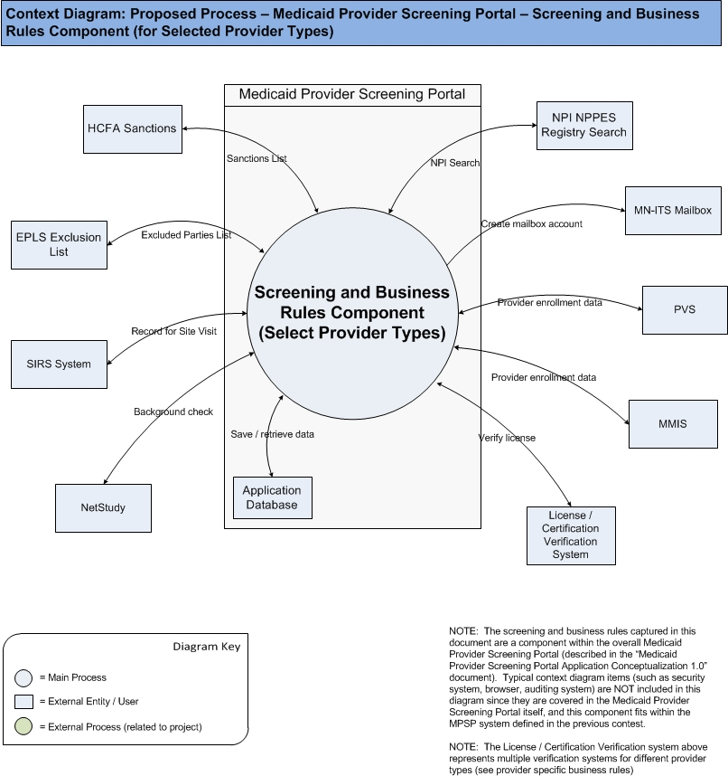

High Level Workflow
The workflow required to complete the primary objectives of the proposed application is described below. The workflow is business-centered, and includes “decision forks” for decisions the business user, or application, must make to achieve the objective. The workflow omits application faults or exceptions. Individual tasks in the workflow are described.

Workflow/Process Map Diagram

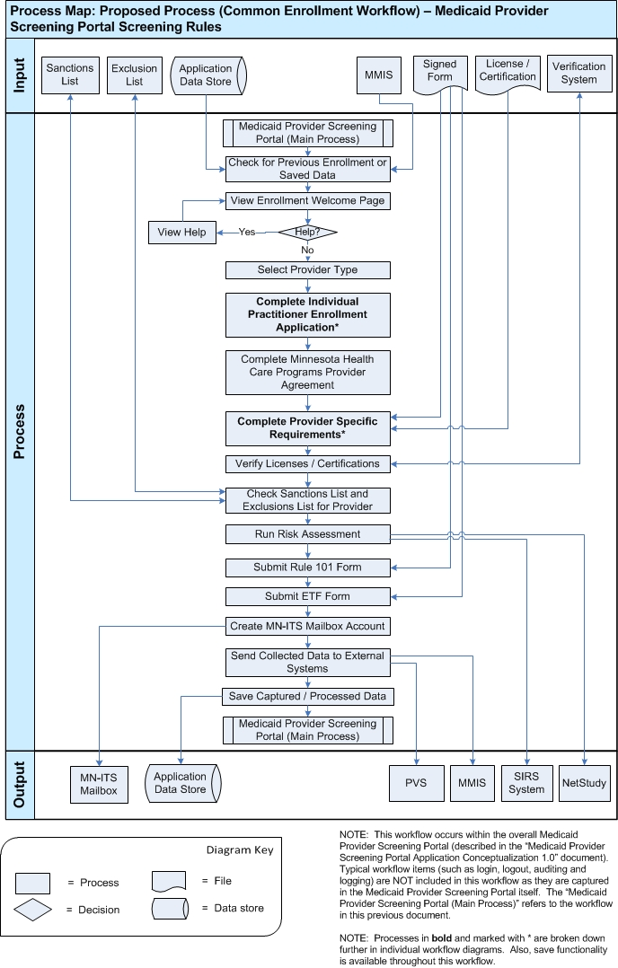
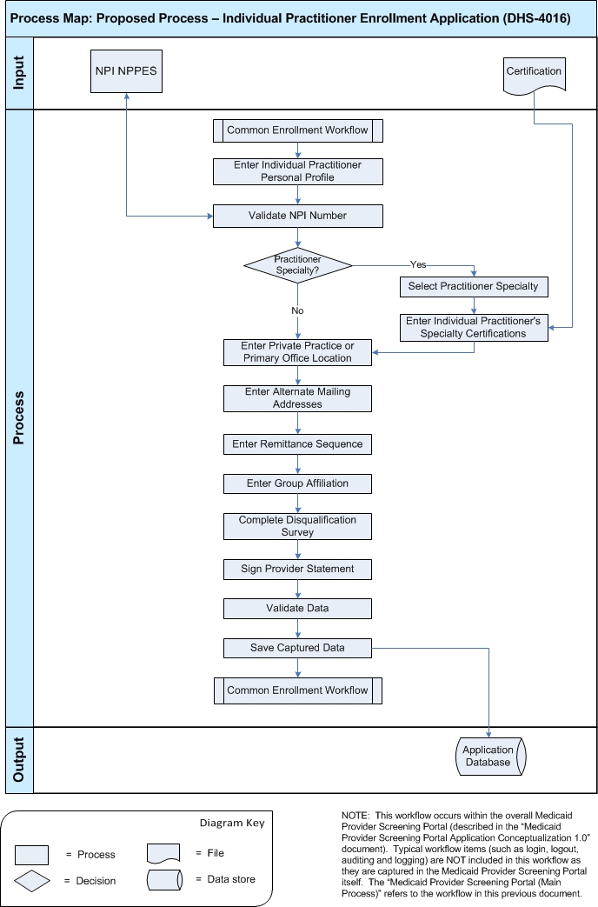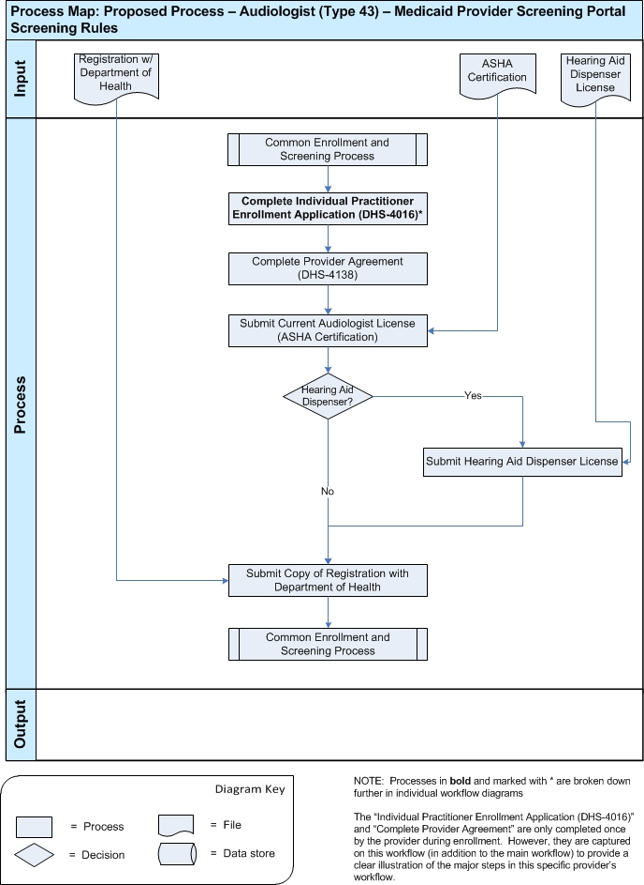
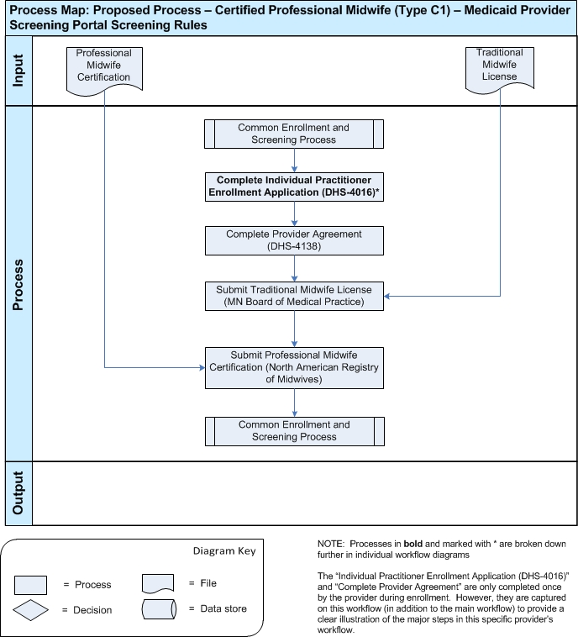
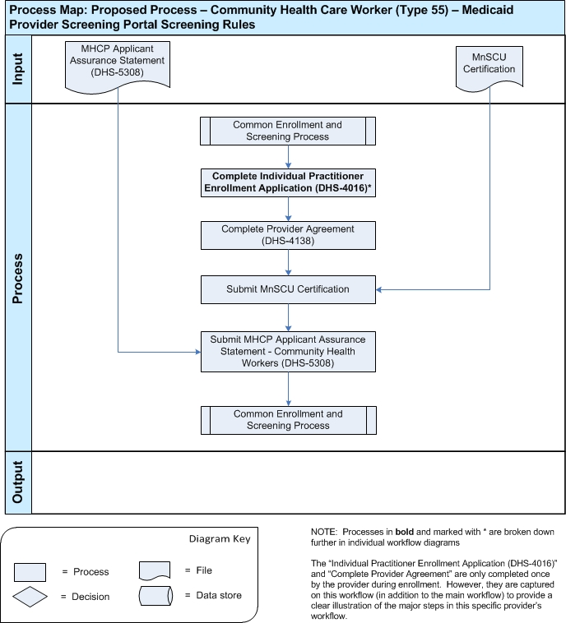
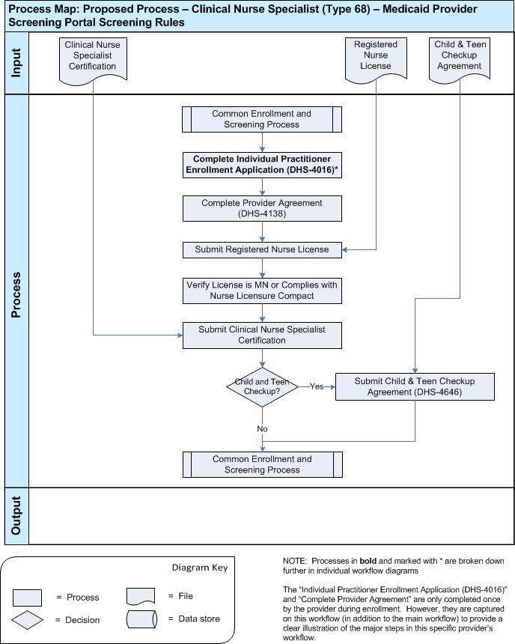
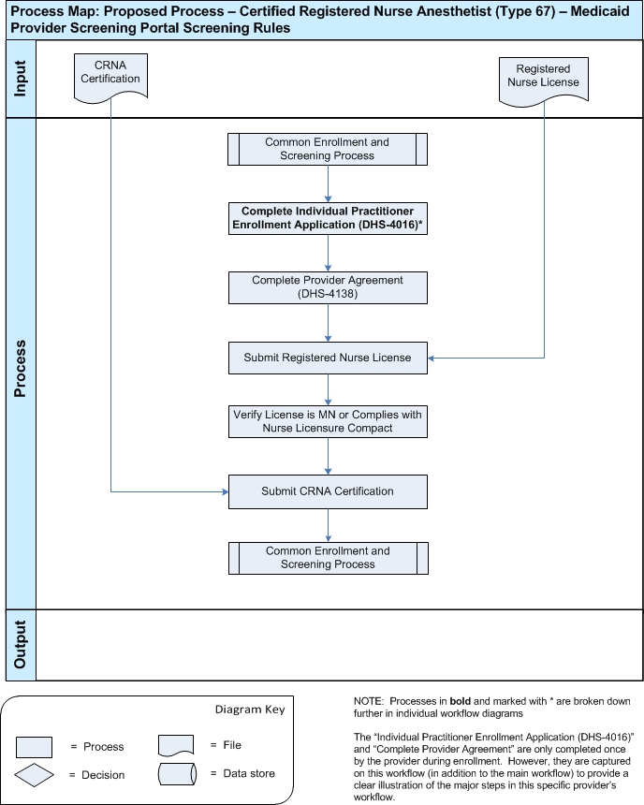
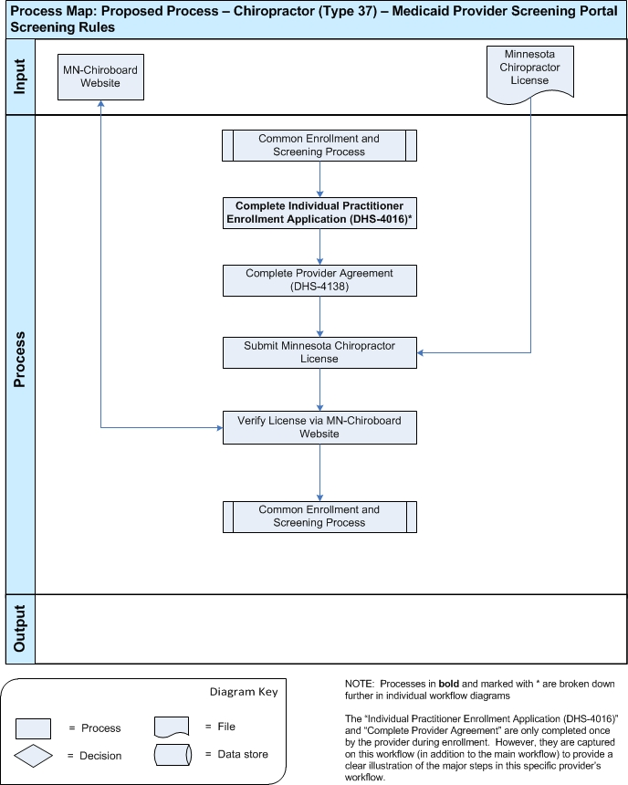
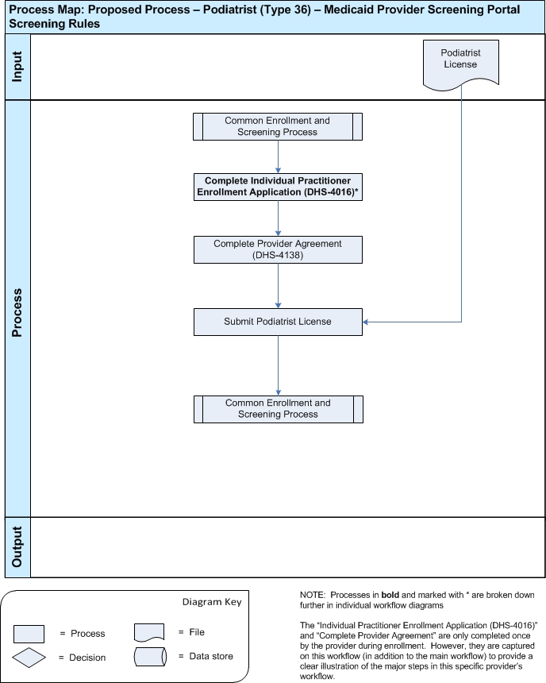
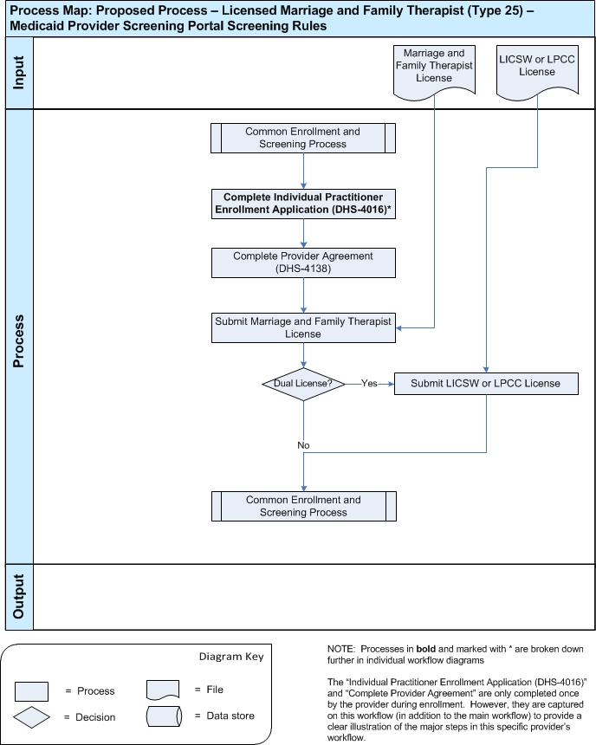
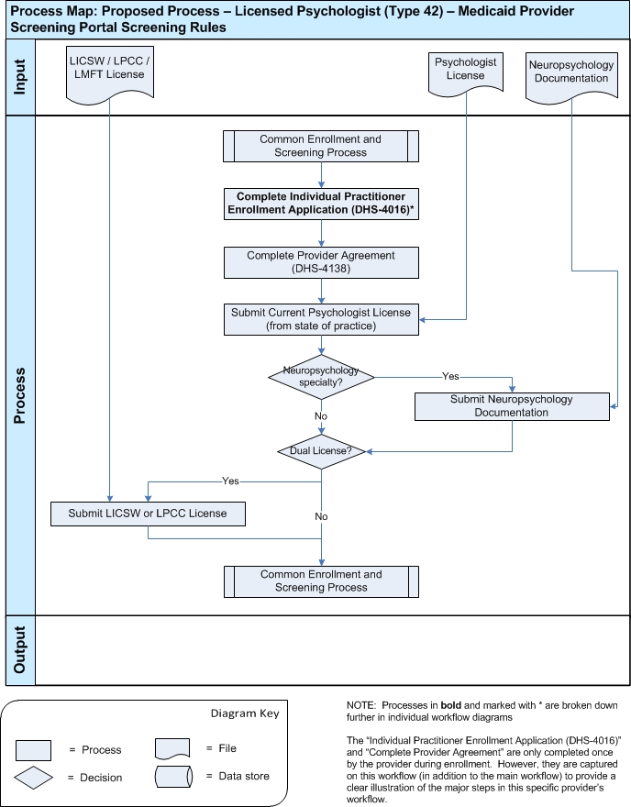

Workflow Description

Main Workflow
- The workflow below is a component of the overall Medicaid Provider Screening Portal application. Users will access the functionality in this workflow from the MPSP application.
- The application will check to see if the user has previously enrolled (re-enrolling) or not (enroll). It will also check to see if the provider is already in the system and has a unique identifier already assigned to them.
- The application will also check for a saved enrollment application
  - If a partially completed enrollment application is found, the user can select to load this data and continue the enrollment process from where they left off.
- The provider enrollment and screening process begins by displaying a welcome page with basic instructions on how to complete the form.
    - Welcome message
    - Contact details
- If the user needs help to complete the enrollment process, they will have the option to view the help page.
- The user will then select their “Provider Type” value. Based on the value selected, the application will keep track of their provider type code.
  - The full list of provider types, along with matching provider codes, is included in section 4.4.
- The user must then complete the “Individual Practitioner Enrollment Application” (NOTE: please see detailed workflow below for all the steps required to complete this application).
- The user must then complete and agree to the Minnesota Health Care Programs (MHCP) Provider Agreement.
- Once all the enrollment information above is collected, the provider specific enrollment steps will begin. This part of the screening and enrollment process will be dynamic, based on a set of business rules for each provider type. (NOTE: These dynamic business rules are defined above in section 3.1).
  - The provider specific workflows are individually described in detail below (for the specific providers covered in this contest).
  - Users will perform the steps required for their provider type (such as submitting licenses, certifications and signed forms).
- Once the user has completed their provider specific workflow, the application will verify the licenses and certifications they submitted.
  - Possible Problem: The system supports a large number of provider types, and each type has multiple licenses or certificates to submit. The ability to verify these licenses and certifications automatically could be very challenging, since each different license could have a different service it needs to connect to for validation. Some of the licensing boards may not even offer a system that is feasible (architecturally) for automatic verification.
  - Possible Opportunity: The opportunity exists to allow scanned images of licenses to be uploaded to the server so they can be verified manually by support staff (similar to the process in the current system).
  - Possible Opportunity: Another opportunity is to automate as many of the license verifications as possible, while allowing manual verification for the ones that can’t be. This will lighten the workload of support staff, while still allowing all types of licenses to be verified. Additional verifications can be added as soon as it’s possible, so eventually all verification could be automatic.
- Next, the application will check the sanctions and exclusions list to confirm the provider is not included on any of them.
  - OIG Exclusion List
  - EPLS Exclusion List
  - Users that are found on these lists have had problems in the past, and their application will be rejected.
  - Possible Problem: It’s possible that these systems could return false positive results. This could be caused by the provider having a similar name or address to someone else who really is on the list.
  - Possible Opportunity: A possible way to solve this problem is to store rejected applications for a certain period of time. Providers can be notified of the rejection, and have the option to request a review by a support staff member. Or a process could be designed so automatically rejected applications are all reviewed (fewer false rejections but more time required).
- After the provider has completed all their required enrollment steps, the application will run the risk assessment rules to calculate the provider’s risk level.
  - Based on the risk level calculated, data will be passed to the appropriate systems:
    - High-risk:
      - SIRS (Surveillance & Integrity Review Section)
      - NetStudy Background Check
    - Moderate risk:
      - SIRS (Surveillance & Integrity Review Section)
    - Limited Risk:
      - Neither of the systems above
    - Possible Opportunity: The system can be designed so this risk assessment process can support addition risk checks or calculations in the future (a modular design).
- Users will then have the opportunity to submit a Rule 101 Provider Assurance Statement if needed.
  - Users only need to agree to Rule 101 when they've decided to limit their patient caseload to 10%-20% (depending on provider type) of Medicaid patients, if they are limiting everyone regardless of insurance, or if they are limiting everyone except children with special health care needs or managed care organization patients.
- The provider will also be able to submit an Electronic Funds Transfer (EFT) Authorization form
- The application will then send a request to the MN-ITS system to create a mailbox account for the enrolling provider.
- Finally, the application will apply “Smart Routing” rules to send the collected data to the appropriate systems based on screening results.
    - MMIS
    - PVS
- The application will then save all collected and processed information to the application database (Previously Successfully Screened Provider Database).

Individual Practitioner Enrollment Application Workflow
- This process will collect enrollment information from the provider (the same information currently collected on the Individual Practitioner Enrollment Application).
- Next, the user will complete the “Individual Practitioner Personal Profile” form. All fields for this form are required to be entered unless stated otherwise (details in section 4.4).
- Based on the “Provider Type” value entered above, the application will determine if the user must complete an Individual Practitioner's Specialty form or submit a provider specific license / certificate.
  - If the enrollee is a physician, dentists, nurse practitioner, private duty nurse, or other provider with a specialty certification required (see provider specific rules in section 3.1), they are required to complete their specific Individual Practitioner's Specialty form:
    - Physician Specialties (if code = 20)
    - Dental Specialties (if code = 30)
    - Nurse Practitioner Specialties (if code = 65)
    - Private Duty Nurse Specialties (if code = 64)
    - Psychology Specialty (if code = 42)
    - The values available for each of the above provider types are detailed in section 4.4.
    - Full details on provider specific license and certificates required are captured in the individual provider workflows below.
- If the enrollee entered a specialty above, they must also submit their Individual Practitioner's Specialty Certifications.
- Next, the user must enter Private Practice or Primary Office Location Information. If the enrollee does not maintain a private practice, they should list their primary office location. Details on the practice and questions that must be answered are included in section 4.4.
- The enrollee can now enter additional mailing addresses (in addition to the “official” mailing address entered above in their profile).
  - If the provider enters alternate addresses, they must also enter which address to send specific mailings:
    - Remittance Advice
    - Reimbursement Check
    - Provider Correspondence
    - Authorization Request Notice and Service Agreements
    - Credentials (Enrollment Status)
- The user must then complete the Remittance Sequence. The value they select will determine if the information should be listed other than alphabetically:
    - Patient Account or Own Reference Number Order
    - DHS Transaction Control Number Order
    - Recipient MHCP ID Number Order
- The enrollee will enter Group Affiliation Information:
- Next, the enrollee must answer the Disqualification Information questionnaire. Answers to this questionnaire will be used to calculate their risk level:
    - Have you ever been convicted of a criminal offense related to involvement in any program under Medicare, Medicaid, Title XX, or Title XXI in Minnesota or any other state or jurisdiction since the inception of these programs? (yes / no)
    - Have you had civil money penalties or assessments imposed under section 1128A of the Social Security Act? (yes / no)
    - Have you ever been excluded or terminated from participation in Medicare, Medicaid, Children's Health Insurance Program (CHIP), or the Title XXI services program in Minnesota or any other state since the inception of these programs? (yes / no)
- Finally, the user must read the Provider Statement and agree the information they are submitting is accurate, complete and truthful.
  - The user must sign or submit a signed copy of this form
    - Possible Problem: Accepting a signature online must meet the necessary legal criteria.
    - Possible Opportunity: There is the opportunity to support the ability for the user to upload scanned images of signed documents to be uploaded to the server and stored.
- Once the user has completed this Individual Practitioner Enrollment Application workflow, they will be returned to the main workflow.

Provider Workflow: Audiologist – Type 43
- Audiologists (provider type 43) are required to complete the following items as part of the enrollment process:
  - Complete the Individual Practitioner Enrollment Application (DHS-4016)
  - Complete the Provider Agreement (DHS-4138)
  - Submit a copy of their current Audiologist License (ASHA Certification)
  - If they are also a licensed hearing aid dispenser:
    - Submit a copy of their Hearing Aid Dispenser License
  - Submit a copy of their registration with the Department of Health
  - During this workflow, provider specific data will need to be entered and exceptions may occur (please see section 3.1 for full details on provider’s business rules).

Provider Workflow: Certified Professional Midwife– Type C1
- Certified Professional Midwives (provider type C1) are required to complete the following items as part of the enrollment process:
  - Complete the Individual Practitioner Enrollment Application (DHS-4016)
  - Complete the Provider Agreement (DHS-4138)
  - Submit a copy of their Traditional Midwife License from the MN Board of Medical Practice
  - Submit a copy of their Professional Midwife Certification from the North American Registry of Midwives
  - During this workflow, provider specific data will need to be entered and exceptions may occur (please see section 3.1 for full details on provider’s business rules).

Provider Workflow: Community Health Care Worker – Type 55
- Community Health Care Workers (provider type 55) are required to complete the following items as part of the enrollment process:
  - Complete the Individual Practitioner Enrollment Application (DHS-4016)
  - Complete the Provider Agreement (DHS-4138)
  - Submit a copy of their MnSCU Certification
    - MnSCU Certification must be from an approved College or Curriculum (see provider rules)
  - Submit the MHCP Applicant Assurance Statement – Community Health Workers (DHS-5308) form.
  - During this workflow, provider specific data will need to be entered and exceptions may occur (please see section 3.1 for full details on provider’s business rules).

Provider Workflow: Clinical Nurse Specialist – Type 68
- Clinical Nurse Specialists (provider type 68) are required to complete the following items as part of the enrollment process:
  - Complete the Individual Practitioner Enrollment Application (DHS-4016)
  - Complete the Provider Agreement (DHS-4138)
  - Submit a copy of their Registered Nurse License in state of practice
    - An exception exists under the Nurse Licensure Compact information (see business rules for details)
      - If the provider is licensed and resides in one state, but practices in another, the license is accepted IF both states participate in the Nurse Licensure Compact. Minnesota does not participate in the NLC, so if the provider practices in MN, they must have a MN RN license and their MN RN license is not accepted in any other state. Example: Provider resides and is licensed in South Dakota (an NLC state) but practices in North Dakota (an NLC state). Provider MUST be licensed in state of permanent residency.
    - The application must validate that MN license has been submitted if the Nurse practices in MN, otherwise they must comply with the Nurse Licensure Compact.
  - Submit a copy of their Clinical Nurse Specialist Certification from the American Nurses Credentialing Center, or other accepted National Board
  - Optional: An option form, the Child & Teen Checkup Agreement (DHS-4646), can also be submitted if they select to.
- During this workflow, provider specific data will need to be entered and exceptions may occur (please see section 3.1 for full details on provider’s business rules).

Provider Workflow: Certified Registered Nurse Anesthetist – Type 67
- Certified Registered Nurse Anesthetists (provider type 67) are required to complete the following items as part of the enrollment process:
  - Complete the Individual Practitioner Enrollment Application (DHS-4016)
  - Complete the Provider Agreement (DHS-4138)
  - Submit a copy of their Registered Nurse License in state of practice
    - An exception exists under the Nurse Licensure Compact information (see business rules for details)
      - If the provider is licensed and resides in one state, but practices in another, the license is accepted IF both states participate in the Nurse Licensure Compact. Minnesota does not participate in the NLC, so if the provider practices in MN, they must have a MN RN license and their MN RN license is not accepted in any other state. Example: Provider resides and is licensed in South Dakota (an NLC state) but practices in North Dakota (an NLC state). Provider MUST be licensed in state of permanent residency.
    - The application must validate that MN license has been submitted if the Nurse practices in MN, otherwise they must comply with the Nurse Licensure Compact.
  - Submit a copy of their CRNA Certification from the American Association of Nurse Anesthetists
- During this workflow, provider specific data will need to be entered and exceptions may occur (please see section 3.1 for full details on provider’s business rules).

Provider Workflow: Chiropractor – Type 37
- Chiropractors (provider type 37) are required to complete the following items as part of the enrollment process:
  - Complete the Individual Practitioner Enrollment Application (DHS-4016)
  - Complete the Provider Agreement (DHS-4138)
  - Submit a copy of their current Minnesota License from the Minnesota Board of Chiropractic Examiners
    - The Chiropractor License can be verified via the licensing website: http://www.mn-chiroboard.state.mn.us/
- During this workflow, provider specific data will need to be entered and exceptions may occur (please see section 3.1 for full details on provider’s business rules).

Provider Workflow: Podiatrist – Type 36
- Podiatrists (provider type 36) are required to complete the following items as part of the enrollment process:
  - Complete the Individual Practitioner Enrollment Application (DHS-4016)
  - Complete the Provider Agreement (DHS-4138)
  - Submit a copy of their current Podiatrist License from the MN Board of Podiatric Medicine or current state of practice
- During this workflow, provider specific data will need to be entered and exceptions may occur (please see section 3.1 for full details on provider’s business rules).

Provider Workflow: Licensed Marriage and Family Therapist – Type 25
- Licensed Marriage and Family Therapists (provider type 25) are required to complete the following items as part of the enrollment process:
  - Complete the Individual Practitioner Enrollment Application (DHS-4016)
  - Complete the Provider Agreement (DHS-4138)
  - Submit a copy of their Marriage & Family Therapist License from the MN Board of Marriage & Family Therapy.
    - Out-of-state providers must meet the MN criteria for licensure (and submit license from state of practice).
- During this workflow, provider specific data will need to be entered and exceptions may occur (please see section 3.1 for full details on provider’s business rules).
  - If provider has a dual license, they must submit their second license:
    - Dual licensed providers: A number of mental health providers are licensed from multiple boards. Providers who are licensed as an LMFT and an LICSW, or LPCC are enrolled with MHCP as LICSWs. Add COS 117 if also an LMFT.

Provider Workflow: Licensed Psychologist – Type 42
- Licensed Psychologists (provider type 42) are required to complete the following items as part of the enrollment process:
  - Complete the Individual Practitioner Enrollment Application (DHS-4016)
  - Complete the Provider Agreement (DHS-4138)
  - Submit a copy of their Psychologist License from state of practice.
  - If a Licensed Psychologist has a Neuropsychology specialty they must submit required certificate:
    - See Licensed Psychologist rules in section 3.1 for details
    - During this workflow, provider specific data will need to be entered and exceptions may occur (please see section 3.1 for full details on provider’s business rules).
      - If the provider has a dual licesne, they must submit the second license for verification.
      - Dual licensed providers: A number of mental health providers are licensed from multiple boards. Providers who are licensed as a Psychologist and an LMFT, LICSW, or LPCC are enrolled with MHCP as Psychologists.

Use Case Diagrams
Use case diagrams are helpful illustrations of how the application’s users interact with the system. Use case “bubbles” correlate to distinct task domains and are useful in determining user roles, module boundaries, shared tasks, etc. The use case diagrams are intentionally high level, and exclude activity details such as for example “submit shopping cart.” The diagram below should be used to verify that the required functionality of the application is covered.

The use case diagrams use the next coloring schema for bubbles:

Color | Description
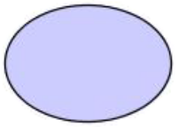 | Regular use case (concrete)
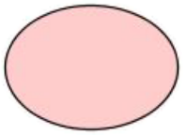 | Aggregate use case
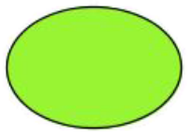 | External use case (not in scope)

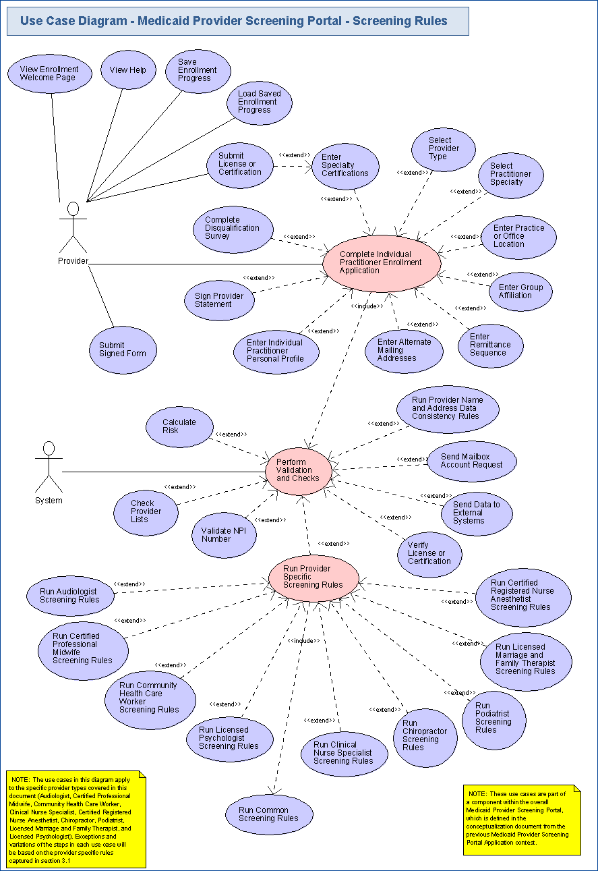

Business Requirements

This section identifies, enumerates and explores the business requirements that must be met by the application. Business requirements include capturing the types of users, the basic inputs and outputs, the system’s dependencies, and the tasks the system should accomplish. Some business requirement for a web-based retail site might include:

Users: “The system supports public browsers, registered members, customer service administrators, and system administrators.”
Tasks: “Users have personalized accounts,” “shopping carts expire in a configurable period, and the default is 10 days”, etc.

It is important to confirm that Task Requirements include all the tasks required to meet the business objectives.

Users
All applications have users and most have several users of different types. This section identifies, at a high level, the types of users of the system.

Provider
The registered user refers to any provider who is logged in and using the application. There are different provider types, and although the business rules differ for each, all Provider users have the same access level in the system. The provider types covered in this document are: Audiologist, Certified Professional Midwife, Community Health Care Worker, Clinical Nurse Specialist, Certified Registered Nurse Anesthetist, Chiropractor, Podiatrist, Licensed Marriage and Family Therapist, Licensed Psychologist (please refer to section 3.1 for Provider Specific Rules).

System
The system is a non-human actor in the application. It represents processes which are initiated by the application (although they may be triggered by user input).

Inputs/Outputs
This section identifies and describes the inputs to and outputs from the new application. Inputs can include electronic inputs, like RSS and EDI feeds, updates from external databases, etc, as well as human inputs, like “user X keys in results from report Y.” Output can include electronic feeds, printed reports, etc. In this section, all electronic inputs and outputs are captured. Human inputs are omitted from this section.

NOTE: For all the licenses and certifications included below, their method of input (typing in the number or submitting a scanned copy) is still an open issue. Please see section 1.5 for details.

Inputs

Data for Individual Practitioner Enrollment Application
The user will type in the values to complete the required fields that are part of the Individual Practitioner Enrollment Application (DHS-4016).

Signed Provider Agreement (DHS-4138)
The user will need to sign and submit the Provider Agreement (DHS-4138) into the system.

NPI Verification Status
The system will receive a response from the NPI NPPES Registry Search system with the status of the NPI number being checked.

OIG Exclusion List Results
The system will receive a response from the OIG Exclusion List with results from the provider check.

EPLS Exclusion List Results
The system will receive a response from the EPLS Exclusion List system with results from the provider check.

MMIS
The component will read in provider data from the MMIS system (such as if the provider already exists in the system).

Saved Enrollment Data
The application will load previously saved enrollment data entered by a provider.

Signed Forms
The user will need to sign and submit the various forms into the system.

License or Certification Verification Results
The system will receive a response from the verification system confirming (or not) that the provider’s license or certification is valid. This input may come from different systems (or even manual approval) since there are many different types of licenses and certifications that must be verified. The details of this verification process are an open issue (see section 1.5). However, where the verification system is known it is included below as specific input.

American Speech-Language-Hearing Association (ASHA) Audiologist Certification
Audiologists must submit their ASHA Certification along with their enrollment application.

Hearing Aid Dispenser License
Audiologists must submit their Hearing Aid Dispenser license (if they are a hearing aid dispenser) along with their enrollment application.

Verification of Audiologist Registration with Department of Health
Audiologists must submit their registration with the MN Department of Health along with their enrollment application.

Traditional Midwife License
Certified Professional Midwives must submit a copy of their Traditional Midwife License from the MN Board of Medical Practice along with their enrollment application.

Professional Midwife Certification
Certified Professional Midwives must submit a copy of their Professional Midwife Certification from the North American Registry of Midwives along with their enrollment application.

MnSCU Certification
Community Health Care Workers must submit a copy of their MnSCU Certification from an approved college or curriculum along with their enrollment application.

MHCP Applicant Assurance Statement - Community Health Workers (DHS-5308)
Community Health Care Workers must complete the form “MHCP Applicant Assurance Statement – Community Health Workers (DHS-5308)” along with their enrollment application.

Registered Nurse License
A Clinical Nurse Specialist and a Certified Registered Nurse Anesthetist must submit a copy of their Registered Nurse License in state of practice along with their enrollment application.

Clinical Nurse Specialist Certification
A Clinical Nurse Specialist must submit a copy of their Clinical Nurse Specialist Certification from the American Nurses Credentialing Center (or other accepted National Board) along with their enrollment application.

Child & Teen Checkup Agreement (DHS-4646)
A Clinical Nurse Specialist has the option to submit the Child & Teen Checkup Agreement (DHS-4646) along with their enrollment application.

CRNA Certification
A Certified Registered Nurse Anesthetist must submit a copy of their CRNA Certification from the American Association of Nurse Anesthetists along with their enrollment application.

Minnesota Chiropractor License
A Chiropractor can submit a copy of their current Minnesota Chiropractor License from the Minnesota Board of Chiropractic Examiners along with their enrollment application.

Verification from MN-Chiroboard Website
A Chiropractor can verify their current Minnesota Chiropractor License through the website of the Minnesota Board of Chiropractic Examiners. Verification results will be received from the website.

Podiatrist License
A Podiatrist must submit a copy of their current Podiatrist License from the MN Board of Podiatric Medicine (or current state of practice) along with their enrollment application.

Marriage and Family Therapist License
A Licensed Marriage and Family Therapist must submit a copy of their current Marriage and Family Therapist License from the MN Board of Marriage & Family Therapy (or current state of practice) along with their enrollment application.

Psychologist License
A Licensed Psychologist must submit a copy of their current Psychologist License from their state of practice along with their enrollment application.

Neuropsychology Documentation
A Licensed Psychologist with a Neuropsychology specialty must submit documentation that meets the MN Neuropsychology requirements (see section 3.1 for acceptable documentation) along with their enrollment application.

Outputs

NPI Verification Request
The system will send a request for NPI verification to the NPI NPPES Registry Search system.

OIG Exclusion List Check Request
The system will send a request to the OIG Exclusion List to check for the enrolling provider.

EPLS Exclusion List Check Request
The system will send a request to the EPLS Exclusion List system to check for the enrolling provider.

License or Certification Verification Request
The system will send a request to the verification system to confirm (or not) that the enrolling provider’s license or certification is valid. This output may be sent to different systems since there are many different types of licenses and certifications that must be verified. The details of this verification process are an open issue (see section 1.5). However, where the verification system is known for a specific license of certification the output request is included.

Help
The application displays help output to the user when requested.

MMIS
The component will output provider data to the MMIS system (existing)

SIRS System
The component will send provider data to the SIRS System if site visits are required (based on risk level).

NetStudy
The component will send provider data to NetStudy for participants who require a background check (based on risk level).

Enrollment Data to Save
The application will save the enrollment data entered by a provider when they complete enrollment or save the progress of their application.

Verification Request to the MN-Optometryboard Website
An Optometrist’s license will be verified through the MN-Optometryboard website. A verification request will be sent to the website as output.

Verification Request to the MN-Chiroboard Website
A Chiropractor’s license will be verified through the website of the Minnesota Board of Chiropractic Examiners. Verification results will be received from the website.

Dependencies
Human inputs are also categorized as dependencies. List all dependencies:

Medicaid Provider Screening Portal Application
The screening and business rules captured in this document are a component within the overall Medicaid Provider Screening Portal. It is dependent on this application for its functionality.

Application Database
The component will save application data into an application database.

NPI NPPES Registry Database
The component depends on the NPI NPPES Registry database in order to run NPI verification. This database is available here: NPPES database.

OIG Exclusion List
The component is dependent on the OIG Exclusion List (http://exclusions.oig.hhs.gov/search.aspx) to check providers against the sanctions / exclusion list.

EPLS Exclusion List
The component depends on the EPLS Exclusion List system (https://www.epls.gov/epls/search.do) in order to check and see if providers are included on the list.

MN-Chiroboard Website
The component is dependent on the website of the Minnesota Board of Chiropractic Examiners (for license verification results).

SIRS System
The component depends on the SIRS System to transfer information about provider site visits.

NetStudy
The component depends on the NetStudy system to transfer data for participants who require a background check.

PVS
The component will share provider data with the PVS system.

MMIS
The component will share provider data with the MMIS system (existing)

MN-ITS Mailbox
The component is dependent on the MN-ITS Mailbox system to create accounts for enrolling providers.

License / Certification Verification Systems
The component is dependent on a number of systems to verify the status of provider licenses and certificates (exact systems are still an open issue).

Human Dependencies:

Please refer to section 4.1 for details.

Task Requirements
Task Requirements correlate to the use cases, above. There should be at least one task for each use case bubble. Each use case should be briefly described. If there are specific requirements related to the use case, they should also be listed. This section captures high-level, basic functional requirements. Detailed requirements will be defined during the Requirements Specification contests.

User Functionality

NOTE: This is a non-standard conceptualization contest with a focus on business rules and workflow. This section expands upon the screening and enrollment component (for selected provider types) contained in the conceptualization document from the previous Medicaid Provider Screening Portal Application contest. The functionality and material from that document (including common functionality such as log in, log out, logging, and auditing) applies here unless it has been modified in this document.

View Help
- This use case is triggered when a user requests to view help.
- The application will display help content for the user to browse through
- Help content will include instructions of how to complete various tasks in the application (how to complete the enrollment forms, how to submit signed forms, contact information if additional help is needed, etc.).
- The help page will also outline the steps in the enrollment process so the user knows what they will have to complete.
- The help page will be setup FAQ style, with sections for both common application functionality as well as provider specific questions.

View Enrollment Welcome Page
- This use case is triggered when a user selects to being the provider enrollment and screening process.
- The provider enrollment and screening process begins by displaying a welcome page with basic instructions on how to complete the form.
  - Welcome message
  - Contact details
- The application will check the database to determine if the provider is currently enrolled.
- The application will also check for any previously saved application data and allow the user to resume the process where they last saved.
- Once the user is ready to complete the process they will select to begin

Load Saved Enrollment Progress
- This use case is triggered when a user requests to load their previously saved enrollment data.
- The system will load the currently saved data and bring the user to the next step they need to complete.

Save Enrollment Progress
- This use case will allow a user to save the current status of their enrollment process while they are working on it.
- The user can choose to save their progress at any point in the process.
- The information the user has currently entered will be saved so they can return to it later.

Select Provider Type
- This use case is triggered at the start of the enrollment and screening process.
- The application will request the user enter what type of provider they are.
- The user will then select their “Provider Type” value. Based on the value selected, the application will keep track of their provider type code (listed below next to each type of provider):
    - Audiologist – Provider Type 43
    - Certified Professional Midwife – Provider Type C1
    - Community Health Care Worker – Provider Type 55
    - Clinical Nurse Specialist – Provider Type 68
    - Certified Registered Nurse Anesthetist – Provider Type 67
    - Chiropractor – Provider Type 37
    - Podiatrist – Provider Type 36
    - Licensed Marriage and Family Therapist – Provider Type 25
    - Licensed Psychologist – Provider Type 42

Enter Individual Practitioner Personal Profile
- This use case is triggered as part of the screening an enrollment process.
- The user will complete the “Individual Practitioner Personal Profile” form. All fields for this form are required to be entered unless stated otherwise in the provider type business rules:
    - Last Name
    - First Name
    - Middle Name
    - NPI (Type 1 Only)
    - Social Security Number
    - Date Of Birth
    - Requested Effective Date
    - Highest Degree Earned (Masters Or Doctorate)
    - Date Degree Awarded Individual Practitioner's Email Address (if applicable)
- If NPI number is not entered (and not required based on provider type) then the application will generate a unique UMPI number.

Select Practitioner Specialty
- If the enrollee is a physician, dentists, nurse practitioner, private duty nurse, or psychologist (codes: 20, 30, 65, 64, 42), they are required to complete the Individual Practitioner's Specialty form.
- The application will determine if the user must complete an Individual Practitioner's Specialty form based on the “Provider Type” value entered by the user above.
- Based on their “Provider Type”, the user can select from the following specialties (if applicable to their provider type):
  - Physician Specialties (if code = 20)
    - Allergy 11
    - Anesthesiology 41
    - Cardiovascular Disease 12
    - Cardiovascular Surgery 91
    - Child Psychiatry 21
    - Colon and Rectal Surgery 50
    - Critical Care CC
    - Dermatology 13
    - Diabetes 06
    - Emergency Services 05
    - Endocrinology 42
    - Family Practice 77
    - Gastroenterology 14
    - General Practice 01
    - General Surgery 51
    - Gerontology 43
    - Gynecology 47
    - Immunology 44
    - Infectious Disease 72
    - Internal Medicine 15
    - Nephrology 92
    - Neurological Surgery 52
    - Neurology 22
    - Obstetrics 46
    - Obstetrics and Gynecology 53
    - Oncology 60
    - Ophthalmology 54
    - Orthopedic Surgery 55
    - Otolaryngology 56
    - Pathology 31
    - Pediatrics 16
    - Peripheral Vascular Diseases or Surgery 74
    - Physical Medicine & Rehabilitation (PM&R) 17
    - Plastic Surgery 57
    - Preventive Medicine 18
    - Primary Care PR
    - Psychiatry 23
    - Pulmonary Disease 19
    - Radiology 32
    - Nuclear Medicine 76
    - Rheumatology 90
    - Telemedicine TD
    - Thoracic Surgery 58
    - Urology 59
    - Other 99
  - Dental Specialties (if code = 30)
    - Dental - General Practitioner 62
    - Endodontist ED
    - Oral Surgery 61
    - Orthodontics 63
    - Pedodontics 64
    - Periodontics 65
  - Nurse Practitioner Specialties (if code = 65)
    - Acute Care Nurse Practitioner 97
    - Adult 37
    - Family 35
    - Geriatric 33
    - Mental Health 82
    - OB/GYN 80
    - Pediatric 34
    - Neonatal 94
    - Women's Health 96
  - Private Duty Nurse Specialties (if code = 64)
    - Registered Nurse (RN) 38
    - Licensed Practical Nurse (LPN) 36
  - Psychology Specialty (if code = 42)
    - Neuropsychology 81

Enter Specialty Certifications
- This use case is triggered if the enrolling provider was required to select a specialty.
- If the provider has a specialty, they will need to enter details for their Individual Practitioner's Specialty Certifications.
  - Type of Specialty (populated automatically from above selection)
  - Certification
  - Number
  - Original Issue
  - Date
  - Renewal End
  - Date
  - Issuing
  - State
- The application will save the certification details.
- See appendix for list of specialty codes associated to each specialty.

Submit License or Certification
- This use case allows providers to submit a certification along with their application
- Certifications are required under the following conditions:
  - If the enrolling provider was required to select a specialty they must upload a certification
  - If the provider specific rules require a certification to be submitted
- The user will select the certification (image file) to upload.
- The application will upload the certification to the application server

Enter Practice or Office Location
- Providers going through the enrollment process will need to enter Private Practice or Primary Office Location Information.
- If the enrollee maintains a private practice and has a Type 2 NPI that identifies the practice, they must also enroll their organization. If the enrollee does not maintain a private practice, they should list their primary office location:
  - Do you maintain your own private practice? (Yes / No)
  - Are you employed and/or independently contracted by a group practice? (Yes / No)
  - Do you maintain your own private practice? (Yes / No)
  - Are you employed and/or independently contracted by a group practice? (Yes / No)
  - Practice Name (if applicable)
  - Group NPI/UMPI (if applicable)
  - Location Address (practice location cannot be a PO Box)
  - City State Zip Code County
  - Office Phone Number Office Fax Number
  - Federal Tax Id Number (if applicable and you are the owner of the practice)
  - Legal Name According To The IRS (do not abbreviate)
  - Minnesota Tax Id (if applicable and you are the owner of the practice)
  - Fiscal Year End (default is 12/31)

Enter Group Affiliation
- Providers going through the enrollment process will need to enter their Group Affiliation information.
- The user will enter the following details:
  - Group Name
  - Group NPI/UMPI
  - Practice Location Address
  - City
  - State
  - Zip Code

Enter Remittance Sequence
- Providers going through the enrollment process can enter a remittance sequence if they wish data in reports sent to them is sorted differently than the default value (alphabetically).
- The optional value they select will determine how the information they receive will be listed (other than alphabetically):
  - Patient Account or Own Reference Number Order
  - DHS Transaction Control Number Order
  - Recipient MHCP ID Number Order
- If no value is entered, the default alphabetical sorting will be used.

Enter Alternate Mailing Addresses
- This use case is triggered if users elect to enter alternative mailing addresses (in addition to their “official” mailing address entered in their profile data).
- The user will input their address details:
  - Name
  - Address
  - City
  - State
  - Zip

Complete Disqualification Survey
- Providers going through the screening and enrollment process must answer the Disqualification Information questionnaire.
- Answers to this questionnaire will be used to calculate their risk level.
- The application will ask the following questions:
  - Have you ever been convicted of a criminal offense related to involvement in any program under Medicare, Medicaid, Title XX, or Title XXI in Minnesota or any other state or jurisdiction since the inception of these programs? (yes / no)
  - Have you had civil money penalties or assessments imposed under section 1128A of the Social Security Act? (yes / no)
  - Have you ever been excluded or terminated from participation in Medicare, Medicaid, Children's Health Insurance Program (CHIP), or the Title XXI services program in Minnesota or any other state since the inception of these programs? (yes / no)
- Based on the answers to these questions, the provider will automatically be assigned a risk level.

Sign Provider Statement
- This use case is triggered once the enrollment form has been completed.
- The user must read the Provider Statement and agree the information they are submitting is accurate, complete and truthful.
- The user will need to enter the following information
  - Provider name
  - Provider Title
  - Date
  - Signature
- The way the user will sign the statement is still an open issue. It could be some method of e-signature, or it could simply be uploading a copy of the signed form (see section 1.5 for details).

Submit Signed Form
- This use case allows providers to submit a signed form along with their application
- Signed forms are required for certain provider types (see business rules).
- The user will select which available form to sign.
- The following are forms that can be signed:
  - Provider Agreement (DHS-4138)
    - The provider must agree to the form by submitting the following information:
      - Name of Person Signing
      - Title
      - Data
      - Signature
  - Electronic Funds Transfer (EFT) Authorization form
  - Rule 101 Form
    - Providers only need to agree to Rule 101 when they've decided to limit their patient caseload to 10%-20% (depending on provider type) of Medicaid patients, if they are limiting everyone regardless of insurance, or if they are limiting everyone except children with special health care needs or managed care organization patients.
  - Enrollment of Community Health Workers (CHWs) in MHCP - DHS-5308-ENG
  - MHCP Applicant Assurance Statement – Community Health Workers (DHS-5308)
  - Collaborative Practice Dental Hygienist Assurance Statement: DHS-6025
  - Certified Mental Health Rehabilitation Professional Assurance Statement (DHS-6095)
  - Child and Teen Checkups Provider Agreement (DHS-4646)
  - Full list of forms available on the MHCP website.
- The details of how the signed form is submitted (e-sign or upload scanned copy) is still an open issue (see section 1.5).

System Functionality

Check Provider Lists
- This use case is triggered when the individual provider application has been completed.
- The system will connect to the sanctions list to verify the user is not on it.
- The system will connect to the exclusions list and verify the provider is not on it.
  - If the provider is found on one of these two lists, their applications will be rejected (and possibly marked for further review based on business rules).

Validate NPI Number
- This use case is triggered when provider NPI is entered.
- The application will connect to the NPI NPPES (National Plan & Provider Enumeration System website) Registry Search Database.
- The system will confirm if the user’s NPI number is valid or not.

Verify License or Certification
- This use case is triggered when the individual provider application has been completed.
- Licenses or certifications submitted by the user must be verified.
- Based on the licenses / certifications submitted, the application will connect to the appropriate external system to verify them.
- The application will request verification for the license or certificate.

Calculate Risk
- This use case is triggered by the system when an application is complete.
- The application will calculate the user’s risk level
- Risk level will be calculated based on provider type and answers to the risk assessment questionnaire.
- The system will determine the risk level (high, moderate, or low) of the applying provider.

Send Data to External Systems
- This use case is triggered by the system after risk has been calculated.
- Based on the provider’s risk level, the application will forward data to external systems
  - PVS
  - MMIS
  - SIRS System
  - NetStudy (when background checks are required)
- The details of where each risk level data is sent to is still and open issue (please see section 1.5)

Send Mailbox Account Request
- This use case is triggered by the system when an application is complete.
- The application will connect to the MN-ITS Mailbox system and request a mailbox account is created for the user.

Run Provider Name and Address Data Consistency Rules
- This use case is triggered when provider name or address data is entered.
- The application will run the Name and Address Data Consistency rules to make sure the data entered conforms to these standards
- Full details of these data consistency rules are defined in section 3.1.

Run Provider Specific Screening Rules
- This use case is triggered when all enrollment forms have been completed and submitted.
- The application will run all common screening rules
- The application will validate the data being submitted against the provider specific screening rules (based on the provider type and rules defined in section 3.1).
- The application will confirm all required documents have been submitted.
- The application will verify all signed forms have been submitted.
- The application will confirm that the provider meets the criteria to enroll for their provider type.
- The provider status for enrollment will be updated in the system based on the results of the screening rules.
- Full details of these select provider screening rules are defined in section 3.1.

Run Common Screening Rules
- This use case is triggered along with the provider specific screening rules.
- The application will run all common screening rules (rules that apply to all provider types)
- The provider status for enrollment will be updated in the system based on the results of the screening rules.
- Full details of these common screening rules are defined in section 3.1.

Run Audiologist Screening Rules
- This use case is triggered for users who are provider type “Audiologist”.
- The application will run all screening rules specific to this provider type.
- Audiologists (provider type 43) are required to complete the following items as part of the enrollment process:
  - Complete the Individual Practitioner Enrollment Application (DHS-4016)
  - Complete the Provider Agreement (DHS-4138)
  - Submit a copy of their current Audiologist License (ASHA Certification)
  - If they are also a licensed hearing aid dispenser:
    - Submit a copy of their Hearing Aid Dispenser License
  - Submit a copy of their registration with the Department of Health
  - During this workflow, provider specific data will need to be entered and exceptions may occur (please see section 3.1 for full details on provider’s business rules).
- The provider status for enrollment will be updated in the system based on the results of the screening rules.
- Full details of these provider specific screening rules are defined in section 3.1.

Run Certified Professional Midwife Screening Rules
- This use case is triggered for users who are provider type “Certified Professional Midwife”.
- The application will run all screening rules specific to this provider type.
- Certified Professional Midwives (provider type C1) are required to:
  - Complete the following items as part of the enrollment process:
  - Complete the Individual Practitioner Enrollment Application (DHS-4016)
  - Complete the Provider Agreement (DHS-4138)
  - Submit a copy of their Traditional Midwife License from the MN Board of Medical Practice
  - Submit a copy of their Professional Midwife Certification from the North American Registry of Midwives
  - During this workflow, provider specific data will need to be entered and exceptions may occur (please see section 3.1 for full details on provider’s business rules).
- The provider status for enrollment will be updated in the system based on the results of the screening rules.
- Full details of these provider specific screening rules are defined in section 3.1.

Run Community Health Care Worker Screening Rules
- This use case is triggered for users who are provider type “Community Health Care Worker”.
- The application will run all screening rules specific to this provider type.
- Community Health Care Workers (provider type 55) are required to complete the following items as part of the enrollment process:
  - Complete the Individual Practitioner Enrollment Application (DHS-4016)
  - Complete the Provider Agreement (DHS-4138)
  - Submit a copy of their MnSCU Certification
    - MnSCU Certification must be from an approved College or Curriculum (see provider rules)
  - Submit the MHCP Applicant Assurance Statement – Community Health Workers (DHS-5308) form.
  - During this workflow, provider specific data will need to be entered and exceptions may occur (please see section 3.1 for full details on provider’s business rules).
- The provider status for enrollment will be updated in the system based on the results of the screening rules.
- Full details of these provider specific screening rules are defined in section 3.1.

Run Licensed Psychologist Screening Rules
- This use case is triggered for users who are provider type “Licensed Psychologist”.
- The application will run all screening rules specific to this provider type.
- Licensed Psychologists (provider type 42) are required to complete the following items as part of the enrollment process:
  - Complete the Individual Practitioner Enrollment Application (DHS-4016)
  - Complete the Provider Agreement (DHS-4138)
  - Submit a copy of their Psychologist License from state of practice.
  - If a Licensed Psychologist has a Neuropsychology specialty they must submit required certificate:
    - See Licensed Psychologist rules in section 3.1 for details
    - During this workflow, provider specific data will need to be entered and exceptions may occur (please see section 3.1 for full details on provider’s business rules).
      - If the provider has a dual licesne, they must submit the second license for verification.
      - Dual licensed providers: A number of mental health providers are licensed from multiple boards. Providers who are licensed as a Psychologist and an LMFT, LICSW, or LPCC are enrolled with MHCP as Psychologists.
- The provider status for enrollment will be updated in the system based on the results of the screening rules.
- Full details of these provider specific screening rules are defined in section 3.1.

Run Clinical Nurse Specialist Screening Rules
- This use case is triggered for users who are provider type “Clinical Nurse Specialist”.
- The application will run all screening rules specific to this provider type.
- Clinical Nurse Specialists (provider type 68) are required to complete the following items as part of the enrollment process:
  - Complete the Individual Practitioner Enrollment Application (DHS-4016)
  - Complete the Provider Agreement (DHS-4138)
  - Submit a copy of their Registered Nurse License in state of practice
    - An exception exists under the Nurse Licensure Compact information (see business rules for details)
      - If the provider is licensed and resides in one state, but practices in another, the license is accepted IF both states participate in the Nurse Licensure Compact. Minnesota does not participate in the NLC, so if the provider practices in MN, they must have a MN RN license and their MN RN license is not accepted in any other state. Example: Provider resides and is licensed in South Dakota (an NLC state) but practices in North Dakota (an NLC state). Provider MUST be licensed in state of permanent residency.
    - The application must validate that MN license has been submitted if the Nurse practices in MN, otherwise they must comply with the Nurse Licensure Compact.
  - Submit a copy of their Clinical Nurse Specialist Certification from the American Nurses Credentialing Center, or other accepted National Board
  - Optional: An option form, the Child & Teen Checkup Agreement (DHS-4646), can also be submitted if they select to.
  - During this workflow, provider specific data will need to be entered and exceptions may occur (please see section 3.1 for full details on provider’s business rules).
- The provider status for enrollment will be updated in the system based on the results of the screening rules.
- Full details of these provider specific screening rules are defined in section 3.1.

Run Chiropractor Screening Rules
- This use case is triggered for users who are provider type “Chiropractor”.
- The application will run all screening rules specific to this provider type.
- Chiropractors (provider type 37) are required to complete the following items as part of the enrollment process:
  - Complete the Individual Practitioner Enrollment Application (DHS-4016)
  - Complete the Provider Agreement (DHS-4138)
  - Submit a copy of their current Minnesota License from the Minnesota Board of Chiropractic Examiners
    - The Chiropractor License can be verified via the licensing website: http://www.mn-chiroboard.state.mn.us/
    - During this workflow, provider specific data will need to be entered and exceptions may occur (please see section 3.1 for full details on provider’s business rules).
- The provider status for enrollment will be updated in the system based on the results of the screening rules.
- Full details of these provider specific screening rules are defined in section 3.1.

Run Podiatrist Screening Rules
- This use case is triggered for users who are provider type “Podiatrist”.
- The application will run all screening rules specific to this provider type.
- Podiatrists (provider type 36) are required to complete the following items as part of the enrollment process:
  - Complete the Individual Practitioner Enrollment Application (DHS-4016)
  - Complete the Provider Agreement (DHS-4138)
  - Submit a copy of their current Podiatrist License from the MN Board of Podiatric Medicine or current state of practice
  - During this workflow, provider specific data will need to be entered and exceptions may occur (please see section 3.1 for full details on provider’s business rules).
- The provider status for enrollment will be updated in the system based on the results of the screening rules.
- Full details of these provider specific screening rules are defined in section 3.1.

Run Licensed Marriage and Family Therapist Screening Rules
- This use case is triggered for users who are provider type “Licensed Marriage and Family Therapist”.
- The application will run all screening rules specific to this provider type.
- Licensed Marriage and Family Therapists (provider type 25) are required to complete the following items as part of the enrollment process:
  - Complete the Individual Practitioner Enrollment Application (DHS-4016)
  - Complete the Provider Agreement (DHS-4138)
  - Submit a copy of their Marriage & Family Therapist License from the MN Board of Marriage & Family Therapy.
    - Out-of-state providers must meet the MN criteria for licensure (and submit license from state of practice).
  - During this workflow, provider specific data will need to be entered and exceptions may occur (please see section 3.1 for full details on provider’s business rules).
    - If provider has a dual license, they must submit their second license:
    - Dual licensed providers: A number of mental health providers are licensed from multiple boards. Providers who are licensed as an LMFT and an LICSW, or LPCC are enrolled with MHCP as LICSWs. Add COS 117 if also an LMFT.
- The provider status for enrollment will be updated in the system based on the results of the screening rules.
- Full details of these provider specific screening rules are defined in section 3.1.

Run Certified Registered Nurse Anesthetist Screening Rules
- This use case is triggered for users who are provider type “Certified Registered Nurse Anesthetist”.
- The application will run all screening rules specific to this provider type.
- Certified Registered Nurse Anesthetists (provider type 67) are required to complete the following items as part of the enrollment process:
  - Complete the Individual Practitioner Enrollment Application (DHS-4016)
  - Complete the Provider Agreement (DHS-4138)
  - Submit a copy of their Registered Nurse License in state of practice
    - An exception exists under the Nurse Licensure Compact information (see business rules for details)
      - If the provider is licensed and resides in one state, but practices in another, the license is accepted IF both states participate in the Nurse Licensure Compact. Minnesota does not participate in the NLC, so if the provider practices in MN, they must have a MN RN license and their MN RN license is not accepted in any other state. Example: Provider resides and is licensed in South Dakota (an NLC state) but practices in North Dakota (an NLC state). Provider MUST be licensed in state of permanent residency.
    - The application must validate that MN license has been submitted if the Nurse practices in MN, otherwise they must comply with the Nurse Licensure Compact.
  - Submit a copy of their CRNA Certification from the American Association of Nurse Anesthetists
  - During this workflow, provider specific data will need to be entered and exceptions may occur (please see section 3.1 for full details on provider’s business rules).
- The provider status for enrollment will be updated in the system based on the results of the screening rules.
- Full details of these provider specific screening rules are defined in section 3.1.

Security Requirements
This section documents, at a high level, the basic security requirements of the application. For example, does the system require the user to log in? Should the user’s identity be authenticated on just this system, or against a central authority? Are there any special or unusual security requirements, like fingerprint scanning?

User Logged in to MPSP
- This project is for a component of the Medicaid Provider Screening Portal Application, which includes the security requirements that also apply to this project. The business process and screening rules from this document are built into the overall Medicaid Provider Screening Portal application so all security requirements will be handled there (including login and authorization).

Performance Requirements
Performance Requirements for the application are defined at a high level below. If there are specific requirements for specific features to perform at a quantifiable level, they too are listed below. These requirements will be developed in more detail when the Requirements Specification is written, in a later phase

The application will achieve a 99.5% uptime

The application will have 24x7 availability

All pages in the application should be loaded in 5 seconds or less after the initial hit.

Medicaid Provider Screening Portal Application Performance
- This project is for a component of the Medicaid Provider Screening Portal Application. The business process and screening rules in this document are built into the overall Medicaid Provider Screening Portal application so they will follow the performance requirements for the overall application.

Data Migration
Data Migration describes the data that needs to be moved from an older or external system to the new system, in order for it to operate at launch. Migration also includes data that must be transferred from the new system to another external system. Any data migration requirements are listed below.

No data migration is required for this project.

Appendix

Data values that are important to this project or used for many different business rules are contained in this section.

Tribal Codes
A common exception in the provider business rules is that providers at a Public Health Service (PHS) Indian Hospital may have current licensure from any state. In these cases, one of the following Tribal Codes should be added to the provider’s Specialties:

- Reservation:
  - FL = Fond Du Lac Indian Reservation
  - GP = Grand Portage Indian Reservation
  - LL = Leech Lake Indian Reservation
  - ML = Mille Lacs Indian Reservation
  - NL = Net Lake Indian Reservation
  - PI = Prairie Island Indian Reservation
  - RL = Red Lake Reservation
  - US = Upper Sioux Indian Reservation
  - WE = White Earth Indian Reservation
  - LS = Lower Sioux Indian Reservation

Categories of Service Codes
Below is a full list of Categories of Service Codes:

Categories of Service
Code | Description
001 | INPATIENT HOSPITAL GENERAL
003 | INPATIENT HOSP PSYCHIATRY
005 | CHILD WLFR TARGETED CASE MGMNT
006 | INPATIENT HOSP REHABILITATION
007 | OUTPATIENT HOSPITAL SERVICES
011 | NURSING FACILITY LEVEL I
013 | ICF-DD
014 | INPATIENT HOSPITAL IMD
015 | INPATIENT LONG TERM HOSPITAL
017 | NURSING FACILITY LEVEL II
019 | DAY TRAINING AND HABILITATION
020 | HOME HEALTH SERVICES
021 | CONSUMER DIRECTED CARE
022 | TRANSITIONAL SERVICES
025 | BIRTH-CENTER-FACILITY-FEE
028 | RTC - DEV DISABILITIES
029 | RTC - MENTAL HEALTH
030 | PHARMACY SERVICES
032 | MEDICAL SUPPLY/DME
033 | MODIFICATIONS AND ADAPTATIONS
034 | FAMILY COUNSELING & TRAINING
035 | BEHAVIORAL PROGRAM SERVICES
036 | TRANSPORT, SPECIAL
037 | TRANSPORT, AMBULANCE
038 | PERSONAL CARE SERVICES
039 | CHILD & TEEN CHECKUP OUTREACH
040 | CHILD AND TEEN CHECKUP
041 | ANESTHESIA
042 | PRIM CARE UTILIZATION REVIEW
043 | PHYSICIAN SERVICES
044 | CASE MANAGEMENT OTHER
045 | DENTAL
046 | MENTAL HEALTH
050 | COGNITIVE THERAPY
051 | PHYSICAL THERAPY
052 | IEP
053 | SPEECH THERAPY
054 | OCCUPATIONAL THERAPY
055 | PODIATRY
056 | AMBULATORY SURGERY
057 | CHIROPRACTIC
058 | AUDIOLOGY
062 | CONSOLIDATED TREATMENT FUND
063 | CTF EXTND CARE/HALFWAY HOUSE
071 | CASE MANAGEMENT MENTAL HEALTH
072 | HOSPICE
073 | INPATIENT HOSP NEO-NATAL ICU
074 | INPT HOSPITAL NON DRG
075 | EYEGLASSES/CONTACT LENSES
076 | PROSTHETICS AND ORTHOTICS
077 | HEARING AIDS
078 | VISION
079 | RADIOLOGY, TECHNICAL COMPONENT
080 | LABORATORY
082 | FED QUALIFIED HEALTH CNTR SVC
083 | RURAL HEALTH CLINIC SERVICES
084 | SWING BED SERVICES
086 | OUTPATIENT HOSP EMERGENCY SVC
087 | END-STAGE RENAL DIALYSIS
088 | PUBLIC HEALTH NURSING
089 | PRIVATE DUTY NURSING
090 | NURSE MIDWIFE SERVICES
091 | NURSE PRACTITIONER SERVICES
092 | NUTRITION SERVICES
093 | CHORE
094 | COMPANION SERVICES
095 | HOME DELIVERED MEALS
096 | HOMEMAKER SERVICES
097 | CARE GIVER TRAINING
100 | ACCESS SERVICES
101 | ACCESS TO APPEAL
102 | ADULT DAY CARE
103 | FOSTER CARE
104 | SUPPORTED EMPLOYMENT SERVICES
105 | SUPPORTED LIVING SERVICES
106 | STRUCTURED DAY PROGRAM SVC
107 | RESPITE CARE
108 | ASSISTED LIVING SERVICES
109 | INDEPENDENT LIVING SKILLS
110 | IN-HOME FAMILY SUPPORT
111 | DEV DISABILITIES SCREENING
112 | PASARR - DD
113 | PASARR - MENTAL HEALTH
114 | EXTENDED HOME HEALTH AIDE
115 | LTC CONSULTATION-PAS
116 | EXTENDED MEDICAL SUPPLIES/DME
117 | EXTENDED MENTAL HEALTH
118 | EXTENDED OCCUPATIONAL THERAPY
119 | EXTENDED PERSONAL CARE
120 | EXTENDED PHARMACY
121 | EXTENDED PHYSICAL THERAPY
122 | EXTENDED PRIVATE DUTY NURSING
124 | EXTENDED RESPIRATORY THERAPY
125 | EXTENDED SPEECH THERAPY
126 | EXTENDED TRANSPORTATION
127 | PPHP - DPA
128 | PPHP - GA
129 | PPHP - MANDATORY
130 | PPHP - SOCIAL HMO
131 | PPHP - SUPPLEMENTAL HMO
132 | PPHP - VOLUNTARY AFDC
133 | PPHP - MSHO
134 | COST EFFECTIVE HEALTH INS
135 | CO PAY - MEDICAL SUPPLY/DME
136 | CO PAY - MENTAL HEALTH
137 | CO PAY - PHARMACY
138 | CO PAY - PHYSICIAN
139 | COLLECTIONS, MISCELLANEOUS
140 | FINANCIAL TRANSACTION
141 | SPENDDOWN COLLECTIONS
142 | BUY-IN PART A
143 | BUY-IN PART B
144 | PREMIUM PAYMENTS/COLLECTIONS
999 | UNABLE TO DEFINE

Specialty Codes
Below is a full list of all available Specialty Codes:

Specialty Codes
Code | Description
001 | GENERAL PRACTICE
002 | FED QUALIFIED COMM HLTH CLIN
003 | FED QUALIFIED MIGRANT HLTH CL
004 | FED QUALIFIED CLINIC HOMELESS
005 | EMERGENCY SERVICES
006 | DIABETES
007 | INPATIENT HOSPITAL PEDIATRIC
008 | INPATIENT HOSPITAL PSYCH
009 | INPATIENT HOSPITAL IMD
010 | STATE PPO
011 | ALLERGY
012 | CARDIOVASCULAR DISEASE
013 | DERMATOLOGY
014 | GASTROENTEROLOGY
015 | INTERNAL MEDICINE
016 | PEDIATRICS
017 | PHYSICAL MEDICINE AND REHAB
018 | PREVENTIVE MEDICINE
019 | PULMONARY DISEASES
020 | COMP OUTPATIENT REHAB FACLTY
021 | CHILD PSYCHIATRY
022 | NEUROLOGY
023 | PSYCHIATRY
024 | PRE-PAID HEALTH PLAN, MED MAN
025 | PRE-PAID HEALTH PLAN, VOLNTRY
026 | PRE-PAID HEALTH PLAN, GAMC
027 | REGIONAL TRT CTR-DEV DISAB
028 | REGIONAL TREATMENT CTR, IMD
029 | REGIONAL TRT CTR, MENTAL ILL
030 | REGIONAL TRT CTR, NURSE FACIL
031 | PATHOLOGY
032 | RADIOLOGY
033 | GERIATRIC NURSE PRACTITIONER
034 | PEDIATRIC NURSE PRACTITIONER
035 | FAMILY NURSE PRAC
036 | LPN, LICENSED PRACTICAL
037 | NURSE PRACTITIONER, ADULT
038 | NURSE, REGISTERED
039 | COMMUNITY HEALTH CLINIC
040 | PUBLIC HEALTH CLINIC
041 | ANESTHESIOLOGY
042 | ENDOCRINOLOGY
043 | GERIATRICS
044 | IMMUNOLOGY
045 | NUTRITION
046 | OBSTETRICS
047 | GYNECOLOGY
048 | RURAL HEALTH CLINIC FREE STND
049 | RURAL HEALTH CLINIC PROV BSED
050 | COLON AND RECTAL SURGERY
051 | GENERAL SURGERY
052 | NEUROLOGICAL SURGERY
053 | OBSTETRICS AND GYNECOLOGY
054 | OPTHALMOLOGY
055 | ORTHOPEDIC SURGERY
056 | OTOLARYNGOLOGY
057 | PLASTIC SURGERY
058 | THORACIC SURGERY
059 | UROLOGY
060 | ONCOLOGY
061 | ORAL SURGEON (DENTISTS)
062 | DENTAL-GENERAL PRACTITIONER
063 | ORTHODONTIA
064 | PEDODONTIST
065 | PERIODONTICS
066 | INDEPENDENT DIAGNOSTIC TESTING
067 | PHARMACY, HOME CARE
068 | PHARMACY, HOSPITAL
069 | PHARMACY, NUCLEAR
070 | PHARMACY, COMMUNITY
071 | PHARMACY, NURSING FACILTY
072 | INFECTIOUS DISEASES
073 | PROSTHODONTICS
074 | PERIPHERAL VASCULAR DIS/SURG
075 | PREVENTIVE MEDICINE
076 | RADIOLOGY & RADIATION THERAPY
077 | FAMILY PRACTICE
078 | FAMILY COUNSELING
079 | FAMILY TRAINING
080 | NURSE PRACTIONER OBGYN
081 | NEUROPSYCHOLOGY
082 | NURSE MENTAL HEALTH
083 | PERSONAL CARE ATTENDANT
084 | SERV FOR CHILD W/HANDICAP PRV
085 | SER FOR CHLD W/HANDICAP FAM M
086 | MEDICAL TRANSPORTATION - AIR
087 | MEDICAL TRANSPORTATION - ALS
088 | MEDICAL TRANSPORTATION - BLS
089 | MEDICAL TRANSPORTATION - SPEC
090 | RHEUMATOLOGY
091 | CARDIOVASCULAR SURGERY
092 | NEPHROLOGY
093 | JOINT COMMISSION ACCREDITED
094 | NURSE PRACTITIONER NEONATAL
095 | PCA CHOICE
096 | NURSE PRACTITIONER WOMENS HLTH
097 | NURSE PRACTITIONER ACUTE CARE
098 | PSYCH 21 OPTION
099 | OTHER
AB | ADULT DAY CARE, BATH
AD | ADULT DAY CARE SERVICES
AL | CD ADOLESCENT
AP | ACUPUNCTURE CERTIFIED
AS | TRIBAL ASSURANCE STATEMENT
AT | ASSISTANT TECHNOLOGY
AV | CAREGIVER ASSESSMENT
BA | BILLING AGENT
BC | CDCS BACKGROUND CHECK
BD | BEHAVIOR PROGRAM BY AIDE
BN | BEHAVIOR PROGRAM BY ANALYST
BP | BEHAVIOR PROGRAM BY PROFESSION
BS | BEHAVIOR PROGRAM BY SPECIALIST
BT | BEHAVIORAL THERAPY
C2 | CD CO-OCCURRING
CA | CASE MANAGEMENT AIDE
CB | CONSOLIDATED BILLING AGENCY
CC | CRITICAL CARE
CD | CONSUMER DIRECTED COMM SUPP
CE | CONSUMER TRAINING AND EDUCATI
CF | CUSTOMIZED LIVING CLASS F
CG | 24HR CUSTOMIZED LIVING CLASS F
CH | 24 HOUR CUSTOMIZED LIVING CL A
CI | CONTRACTED INDIVIDUAL
CL | CUSTOMIZED LIVING CLASS A
CM | CDCS MANDATORY CASE MGT
CN | COMPANION CARE/SERVICES
CO | CASE MANAGEMENT ONGOING
CP | CRISIS RESPITE, SPECIALIZED
CR | CRISIS RESPITE
CS | CHORE SERVICES
CT | CAREGIVER TRAINING AND EDUCAT
CV | CASE MANAGEMENT CONVERSION
CW | CD CLIENT WITH CHILD
DA | DT&H PILOT RATE A
DB | DT&H PILOT RATE B
DC | DT&H PILOT RATE C
DD | DT&H PILOT RATE D
DO | AC DISCRETIONARY SERVICES
DS | MED SUPPLY DAILYSIS
DT | DT&H TRANSPORTATION
EA | 24HR EMERGENCY ASSISTANCE
ED | ENDODONTISTS
EV | ELIGIBILITY VERIFICATION VEND
FA | FOSTER CARE CORPORATE
FC | FAMILY COUNSELING
FF | FOSTER CARE ADULT FAMILY
FK | FOSTER CARE CHILD
FL | FOND DU LAC INDIAN RESRV
FT | FAMILY TRAINING
GP | GRAND PORTAGE INDIAN RESRV
GT | GAMBLING TREATMENT
HA | HOUSING ACCESS COORDINATION
HB | CD HOSPITAL BASED INPATIENT
HD | HOME DELIVERY MEALS
HF | 24HR CUSTOMIZED CLASS F FADS
HH | HOME HEALTH - AIDE AND EXTEND
HI | HOME INFUSION PHARMACY
HM | HOMEMAKER SERVICES
HS | 24HR CUSTOMIZED CLASS A FADS R
IC | INDEP LIV SKILLS, COUNSELING
IF | IN-HOME FAMILY SUPPORT
IG | INDEP LIV SKILLS, GRP THERAPY
II | INDEP LIV SKILLS, IND THERAPY
IM | INDEP LIV SKILLS, MAINTENANCE
IN | PERSONAL INSTALLATION
LC | LIVE-IN CAREGIVE EXPENSES
LL | LEECH LAKE INDIAN RESRV
LS | LOWER SIOUX
M1 | CD MEDICATION ASST THER-METH
M2 | CD MEDICATION ASST THER-OTHER
M3 | CD MEDICATN ASST THER-METH+
M4 | CD MEDICATN ASST THER-OTHER+
MC | MEDICARE CARRIER
MD | MODIFICATIONS/ADAPTATIONS
ML | MILLE LACS INDIAN RESRV
MS | CD MEDICAL SERVICE
ND | DONT-PUBLISH-IN-DIRECTORY
NL | NETT LAKE INDIAN RESRV
NP | DT&H PILOT WAIVER NON-PILOT
NR | CD NON-RESIDENTIAL TREATMENT
NS | NIGHT SUPERVISION
NT | NUTRITIONAL SERVICES
OA | OCCUPATIONAL THERAPY,ASST EXT
OT | OCCUPATIONAL THERAPY, EXTENDED
PA | PHYSICAL THERAPY,ASST EXTENDED
PC | PERSONAL CARE PROVIDER ORG
PD | RN AND LPN, NON-EXTENDED
PI | PRAIRIE ISLAND INDIAN RESRV
PR | PRIMARY CARE
PS | PERSONAL SUPPORT
PT | PHYSICAL THERAPY, EXTENDED
PU | PERSONAL PURCHASE
PV | PREVOCATIONAL SERVICES
QS | QUALIFIED SUPERVISOR
R1 | CD RESIDENTIAL TREATMENT-HIGH
R2 | CD RESIDENTIAL TREATMENT-MED
R3 | CD RESIDENTIAL TREATMENT-LOW
RB | CD RM & BOARD W/TRMT ONE LOCAT
RC | RESPITE, CERTFIED FACILITY
RH | RESPITE, HOSPITAL
RI | RESPITE CARE SERVICES, IN HOME
RL | RED LAKE INDIAN RESRV
RM | CD RM & BOARD W/TRMT TWO LOCAT
RO | RESPITE CARE SERVICES,OUT HOME
RS | RESIDENTIAL CARE SERVICES
RT | RESPIRATORY THERAPY, EXTENDED
S1 | CD SPECIAL POPULATIONS
SA | SLS, CHILD
SC | SLS, ADULT, CORPORATE AFC
SD | STRUCTURED DAY
SE | SUPPORTED EMPLOYMENT
SL | SUPPORTED LIVING SVCS, ADULT
SM | SHAKOPEE MDEWAKANTON SIOUX
SN | SKILLED NURSING
SP | NOT APPLICABLE
SR | PERSONAL SERVICE FEE
SS | SPECIALIST SERVICE
ST | SPEECH THERAPY, EXTENDED
SU | SUPPLIES/ EQUIPMENT (AC)
SX | SUPPLIES/ EQUIPMENT EXTENDED
TA | TRANSPORTATION - EXTRA ATTDT
TD | TELEMEDICINE
TE | TELEHOMECARE
TF | TRANSITIONAL SVCS,FURNITURE
TH | TRANSITIONAL SVCS,HOUSELD FURN
TL | TELERADIOLOGY
TM | TRANSPORTATION - MILEAGE COM
TN | TRANSPORTATION - MILEAGE (NON)
TP | HEALTHCARE DATA TRADING PART
TR | TRANSPORTATION - AC 1 WAY TRIP
TS | TRANSITIONAL
TW | TRANSPORTATION - WAIVER TRIP
US | UPPER SIOUX INDIAN RESRV
WC | WHEELCHAIR TRANSPORT
WE | WHITE EARTH INDIAN RESRV

License Codes
Below is a full list of all available License Codes:

License Codes
Code | Description
01 | INPATIENT HOSPTITAL CERT
02 | OUT PATIENT CERTIFIED
03 | HOSPICE CERTIFIED
04 | RENAL DIALYSIS CENTER CERT
05 | ICF DD CERTIFIED
06 | NURSING FACILITY I CERT
07 | NURSING FACILITY II CERT
08 | NURSING FACILITY I AND II CERT
10 | RULE 29 LICENSE
11 | REHABITATION AGENCY CERT
12 | COMPRHNSV OUTPTNT REHAB FACLTY
13 | COMMUNITY HEALTH WORKERS
14 | LICSW LICENSE
15 | NUTRITION PROFESSIONAL
17 | REGIONAL TREATMENT CENTER CERT
19 | DAY TRAINING AND REHAB (RULE 3
20 | PHYSICIAN LICENSE
21 | PHYSICIAN ASSISTANT
22 | AMBULATORY SURGICAL CNTR CERT
25 | MARRIAGE AND FAMILY THERAPIST
26 | MENTAL HEALTH REHAB SPECIALIST
29 | OCCUPATIONAL THERAPIST IND PRA
30 | DENTAL LICENSE
31 | DENTAL HYGIENIST
35 | OPTOMETRY LICENSE
36 | PODIATRY LICENSE
37 | CHIROPRACTIC LICENSE
38 | PCA BACKGROUND CLEARANCE
39 | PHYSICAL THERAPIST IND PRAC CE
40 | CERTIFICATE OF CLINICAL COMPET
41 | MAMMOGRAM CERTIFICATION
42 | PSYCHOLOGY LICENSE
43 | AUDIOLOGIST
44 | CASE MANAGEMENT (RULE 74)
47 | PHARMACIST LICENSE
50 | INTENSIVE RESIDENTIAL TRTMT SV
52 | FEDERALLY QUALIFIED HEALTH CTR
53 | RURAL HEALTH CLINIC CERTIFICTN
59 | CLASS A HOME CARE
60 | HOME HEALTH AGENCY CERT
61 | PUBLIC HEALTH NURSING
62 | CONSOLIDATED FUND OUTPATIENT
63 | CONSOLIDATED FUND RESIDENTIAL
64 | RN LICENSE
65 | ADULT NURSE PRACTITIONER CERT
66 | MIDWIFE CERTIFICATION
67 | CRNA CERTIFICATION
68 | CLINICAL NURSE SPEC IN MH NURS
69 | LPN LICENSE
70 | PHARMACY LICENSE
71 | GERIATRIC NURSE PRACTITIONER C
72 | PEDIATRIC NURSE PRACTITIONER C
73 | FAMILY NURSE PRACTITIONER CERT
74 | OBGYN NURSE PRACTITIONER CERT
75 | NEONATAL NURS PRAC CERT
76 | WOMENS HLTH CARE NP
77 | HEARING AID DISPENSE CERT
78 | ACUTE CARE NP
80 | INDEPENDANT LAB CERTIFICATION
81 | PORTABLE X-RAY CERTIFICATION
82 | MEDICAL TRANSPORTATION LICENSE
83 | BIRTH CENTER LICENSE
84 | BIRTH CENTER CERTIFICATION
85 | MIDWIFE LICENSE
86 | FOSTER CARE
99 | OTHER
AA | LEAD AGENCY APPROVED
AC | ADVANCED DENTAL THER CERT
AD | ADC LICENSE
AF | AFC LIC 9555.5050 TO 9555.6265
AP | ACUPUNCTURIST
AT | REGIST ART THERAPIST PLUS EDUC
BA | BEHAVIOR ANALYST PLUS EXPERIEN
BC | SOCIAL WORK BACCALAUREATE DEGR
BS | ASSOCIATES-DEGREE PLUS EXPERIE
C0 | AL-CLASS F-1-4 UNDER AGE 55
C1 | CLS CLASS A HWS>3 UNITS
C2 | CLS CLASS A HWS 1-5 PEOPLE AFC
C3 | CLS CLASS A HWS 5 OR MORE PEOP
C4 | CLS CLASS F HWS>3 UNITS
C5 | CLS CLASS F HWS 1-5 PEOPLE AFC
C6 | CLS CLASS F HWS 5 OR MORE PEOP
C7 | AL-CLASS A-BEFORE 5/1/2001
C8 | AL-CLASS F-BEFORE 5/1/2001
C9 | AL-CLASS A-1-4 UNDER AGE 55
CB | MINIMUM TRAINING PLUS PSYCHOLO
CC | LIC PROFESS CLINICAL COUNCELOR
CF | CHILD FC LICENSE PLUS CERTIFIC
CH | CHAPTER 245B LICENSE
CL | AGY-CLASS-B,C,F
CM | COMMUNITY-MENTAL-HEALTH-CENTER
CN | CORP FOR NAT & COMMUNITY SERV
CT | CARF-CERTIFICATION
DA | DHS APPROVED
DC | DHS CERTIFIED
DD | MEDICAL VENDORS
DT | DENTAL THERAPIST LICENSE
ET | 144A.43-144A.46 & RULE 9565.12
EV | MEDICAID ENROLLED VENDORS
EW | AFC LIC 9555.5050 TO 9555.6265
EX | STATUTE 157.17 PLUS CADI,BI
FA | FAMILY ADC LICENSE 245A.143
FS | FISCAL-SUPPORT-ENTITY
HC | HEALTH CARE PROF PLUS EXPERIEN
HO | HOSPITAL LIC 144.50 TO 144.58
HS | CERTIFICATION OF HLTH, SAFETY,
L1 | 24HR AL CLASS A AFC <5
L2 | 24HR AL CLASS F AFC <5
LA | LEAD AGENCY (CNTY, TRIBAL,HP)
LC | AFC LIC PLUS CERTIFICATION
LH | LICENSED HOME CARE AGENCY UNDE
MT | CERTIFIED MUSIC THERAPIST PLUS
OR | NATIONAL DISEASE ORGANIZATIONS
P1 | ONLINE PCA TRAINING
PA | PCA
PC | PCA CHOICE PROVIDER
PO | PERSON CARE PROVIDER ORGANIZAT
PS | LICENSE OR CERTIFICATE PLUS ST
PY | PSYCHOLOGIST LICENCE UNDER MN
QD | QUALIFIED DIETICIAN
QM | QUALIFIED DEVELOPMNT DISABLTES
QR | QUAL DD PROFES MEETS 9525.1850
RA | REHABILITATION AGENCY
RD | REGISTERED DIETICIAN
RS | MEETS STATUTE 157.17 & CAP 4OR
SP | STRUCTURED PEST CONTROLLED APP
SR | PROVIDER-COMPLIANCE W STATUES
ST | MEETS STATUTE 157.17 & CAP GT4
TR | CERTIFIED THERA REC SPECIALIST
VA | COUNTY APROVE VARIANCE
VT | VOCATIONAL/TECHNICAL COLLEGE
ZW | COMMON CARRIERS OR SPEC TRANS
ZX | OUT OF HOME FACILITY
ZY | HOME DELIVERED MEAL VENDOR
ZZ | PROFESSIONAL STAFF

Major Program Codes
Below is a full list of all available Major Program Codes:

Major Programs
Code | Description
AC | ALTERNATIVE CARE
BB | MINNESOTACARE ADULTS=<200% FEDERAL POVERTY GUIDELINES
CC | CHILDRENS HEALTH PLAN *
DD | CHILDRENS HEALTH PLAN/SCH COMBINED *
DM | DEMONSTRATION TO MAINTAIN INDEPENDENCE AND EMPLOYMENT
EC | STATE PAID EMERGENCY GENERAL ASST MED *
EE | MN CHILDREN W SPECIAL HEALTH NEEDS EVALUATION (HLTH DEPT) *
EH | FEDERALLY PAID EMERGENCY MEDICAID
FF | MINNESOTACARE PARENTS=<275% FEDERAL POVERTY GUIDELINES
FP | FAMILY PLANNING PROGRAM
GM | GENERAL ASSISTANCE MED CARE *
HH | INS EXTENSION PGM (STATE-ADM)
IM | IMD: INST FOR MENTAL DISEASE
JJ | MCRE NONCITIZEN PARENTS=< 275% FEDERAL POVERTY GUIDELINES
KK | MINNESOTACARE NONCITIZEN KIDS/PWS
LL | MINNESOTACARE CITZ KIDS/PHYSICIAN WELLNESS SERVICES
MA | FEDERALLY PAID MEDICAL ASSIST
NM | STATE-PAID MEDICAL ASSISTANCE
OO | CONSOLIDATED TREATMENT FUND
P | PREPAID HEALTH PLAN - MA *
QM | QUALIFIED MEDICARE BENEFICIARY
RM | REFUGEE
SL | PART B PREMIUMS ONLY (SERVICE LIMITED MEDICARE BENEFICIARY)
TT | MN CHILDREN W SPECIAL HEALTH NEEDS TREATMENT (HEALTH DEPT)*
UN | SCREENED--NOT PLACED ON WAIVER/ALTERNATIVE CARE
VV | PRESCRIPTION DRUG PROGRAM *
WD | QUALIFIED WORKING DISABLED
XX | MINNESOTACARE ADULTS>200% FEDERAL POVERTY GUIDELINES
YY | MINNESOTACARE/SCH COMBINATION*
ZZ | PREPAID HEALTH PLAN - GENERAL ASSISTANCE MEDICAL CARE *

